Xander Fries
CS4 Final Project Spec

Cat Chalet
“It’s Pre-Alpha Club Penguin, but with Cats”
Definition of chalet
1: a remote herdsman's hut in the Alps
Cat Chalet will be a visual online community hub with global chat and minigames, heavily inspired by Club Penguin. Players will create accounts and custom cat avatars which they will control in a 2.5-dimensional finite-room world, and interact with other players. Room-level chat similar to IRC is available, with the addition of cartoon speech bubbles showing spoken text to avoid breaking the visual immersion of the world. A standard account-based friend system and direct messaging will also be available, and in-game UI will allow adding friends without switching screens or going through a flow-breaking menu. Given sufficient time, multiplayer mini-games equipped with highscore boards and personal rooms that users can customize and host friends at will be added.
The client-side visual experience will be implemented in Javascript and HTML5 Canvas (ideally even the account creation process will be canvas-based to keep the feel of the site consistent, but that’s low priority). Account-tied information such as usernames/passwords, friends, highscores, and avatar appearance will be handled by MySQL. Volatile real-time information such as player position and simulation state will be handled by PHP using Ratchet, a library providing PHP with tools for WebSockets. If competitive minigames are implemented, care will be taken to isolate application logic to the server to avoid hacking (ex: if a user is in a maze and the client-side naively sends position information to the server, the user can teleport to the end of the maze with a simple console command).
The intended users of Cat Chalet are the entirety of Lakeside School. It would be very entertaining if this turned into a little forum where people would go unironically to chat with random Lakesiders and play low-quality minigames. To call this a success, I think I need to at least get the CS4 classes addicted to walking around with cat avatars and fussing with room decorations.

Feature Prioritization

Must Implement (in order):
- A real-time 2.5-dimensional server where users walk around controlling cartoon cat avatars (at this stage temporary user IDs are assigned to each connection)
- Server-based chat with assisting visual elements
- Account creation allowing for avatar customization (a guest system providing temporary avatars and usernames will exist for on-boarding)
- Art. It can be bad, but it needs to exist. This pass will probably involve skeletal animation and ambient visual effects, as well as some sound things. Also fix up the UI.
- Friends and direct-messaging (and assisting UI)
- Multiple rooms. This means multiple server compartments AND multiple visually different rooms with different mechanical features. Default chat is now room-based.

Should Implement (in order):
- Mini-games with a high-score system. Two possible routes for this: room-based games (either multiplayer or singleplayer) or challenge-based games where you walk up to someone and interact.
- An inventory system. Two types of possessions exist: apparel (stuff you wear) and decorations. Mini-games sometimes give out different rewards based on performance and luck, but often reward nothing.
- Personal account-based customizable rooms. These rooms may be furnished with decorations earned from mini-games, and users can invite friends over to their rooms to have private parties.
- Possession trading. At this point there should be 3 or 4 minigames, each with 10 rewards of varying rarities. Users can trade possessions with friends, and there are certain apparel collections that create a visual effect visible to all players (sparkles, rainbows, etc.). Apparel was already globally visible, but this should tweak the obtrusiveness of rare items to encourage trading.
- Add a high-quality game with lots of replayability - a great example is card-jitsu from Club Penguin. This game should encourage players to keep coming back to climb the global rankings and increase their ability. A card game would work well for this, but other collectible-based mechanics could work well (maybe apparel has stats which determine attack and defense, and this game is a kitty sword fight?).

Design Overview
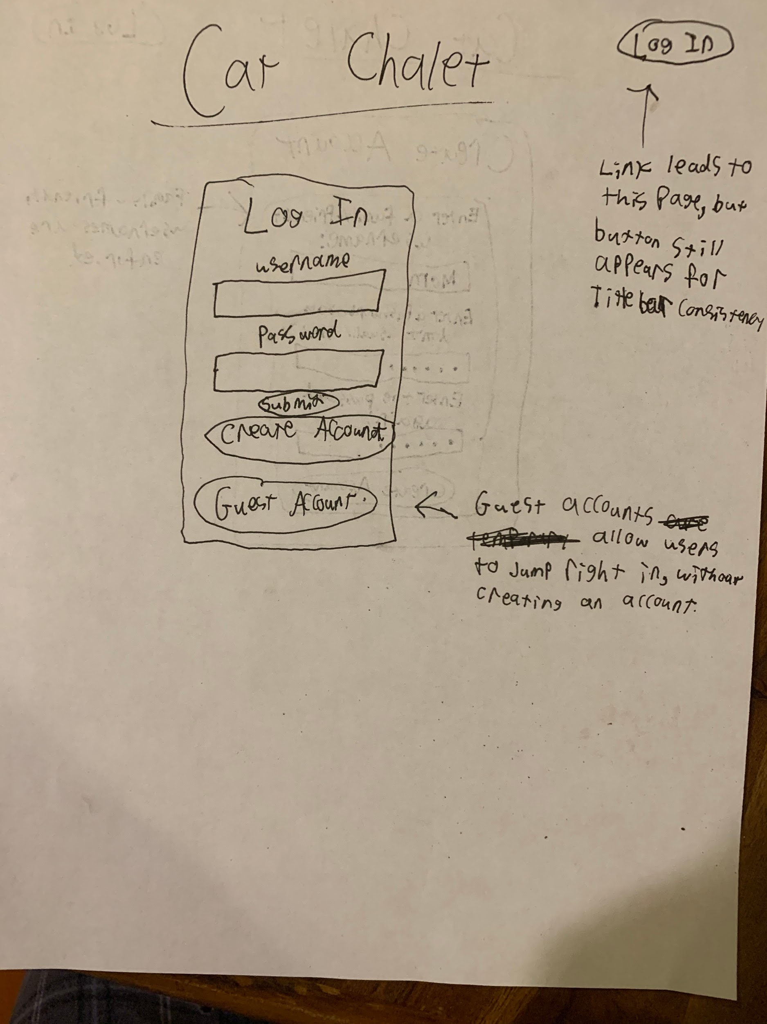
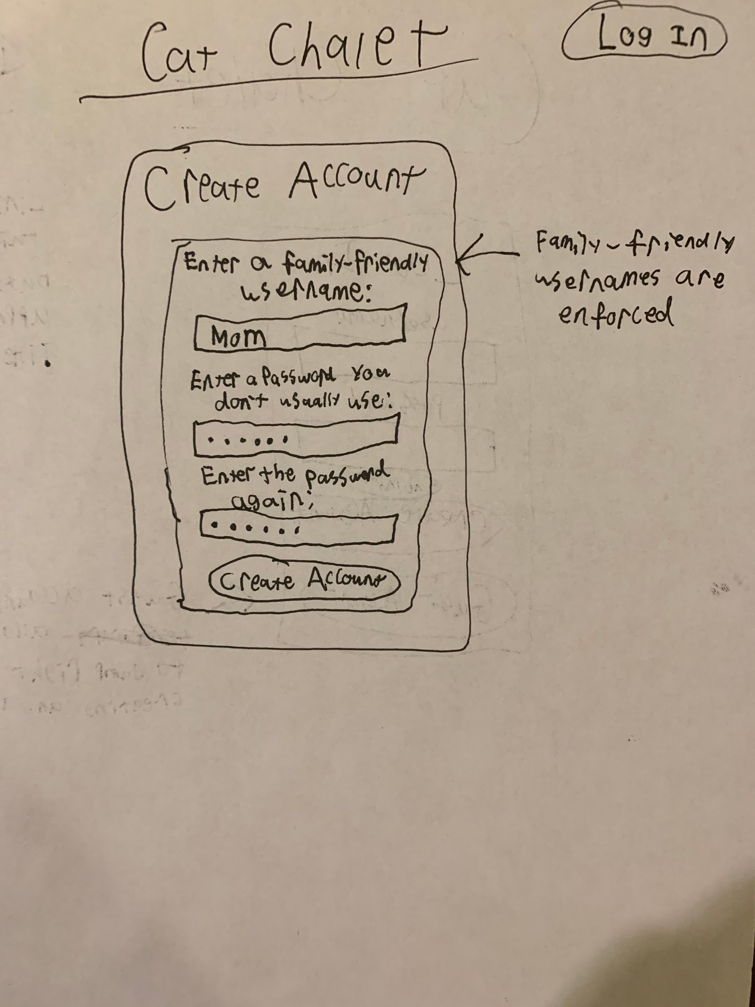

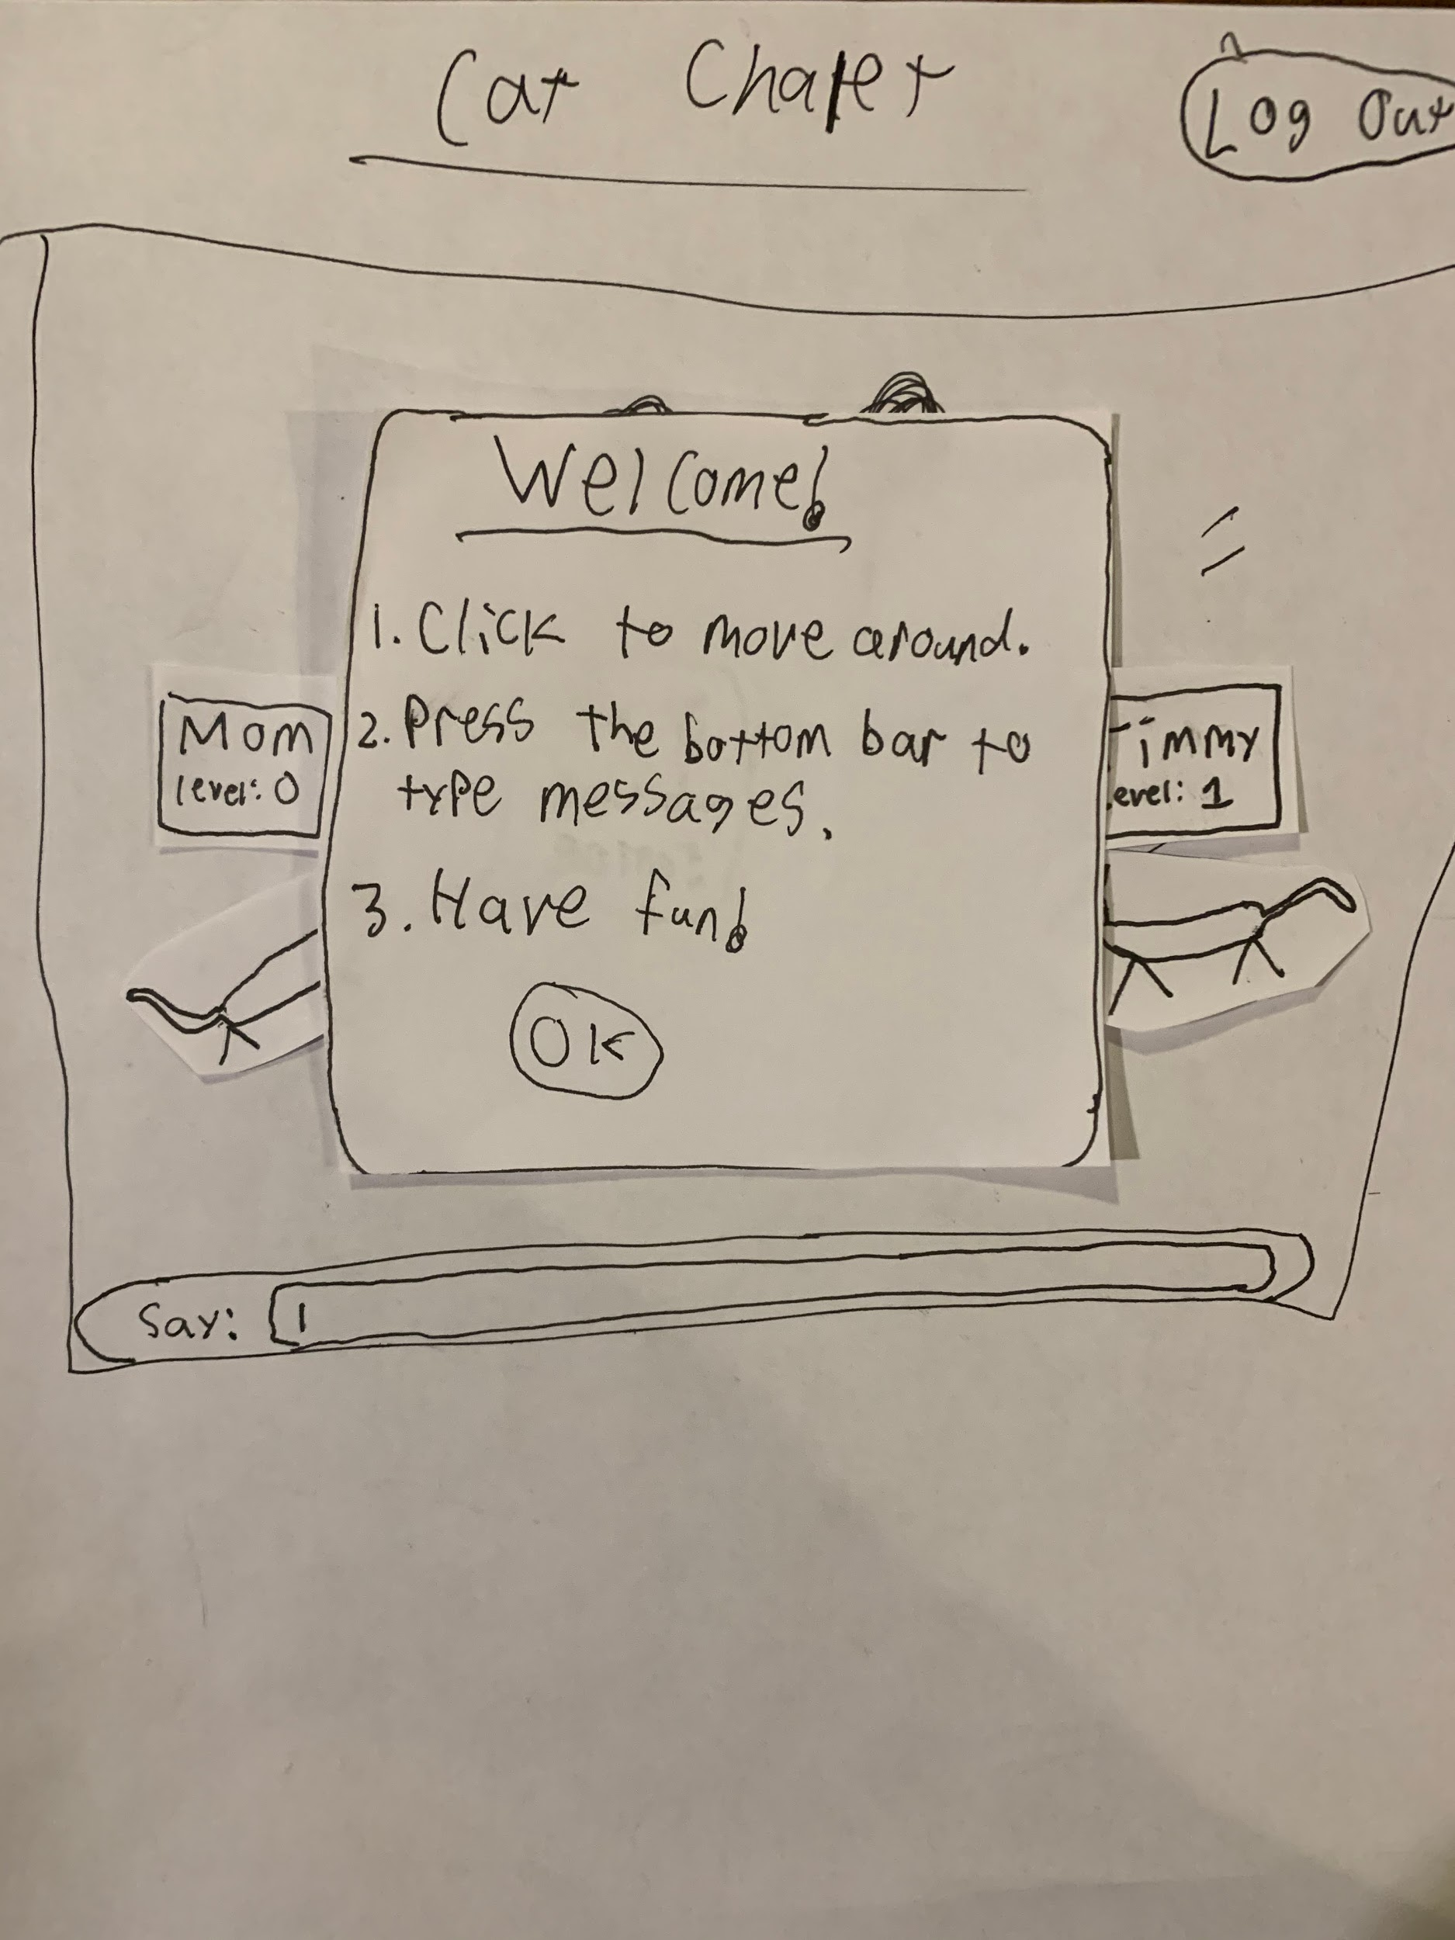

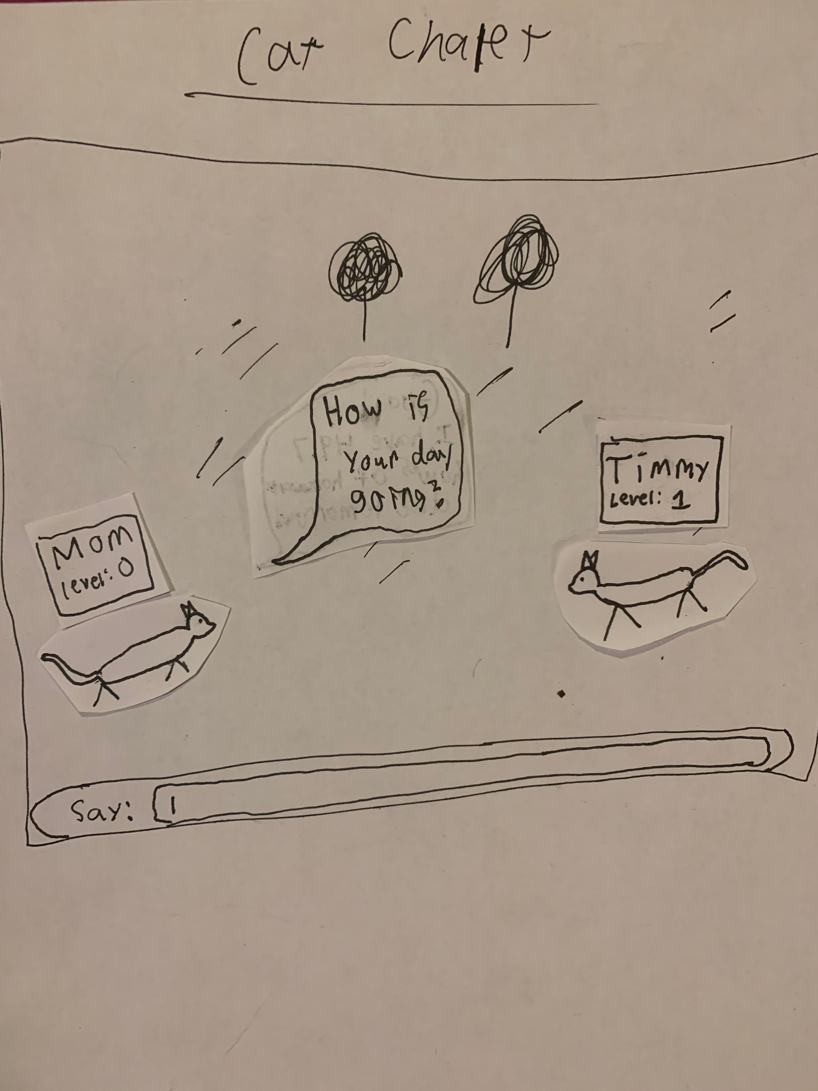
Design Testing Results

My mom and brother tested the low-fidelity design. My mom said the submit button was too small on the login page, and that ‘Guest Account’ should be renamed to ‘Play As Guest’. My brother thought I should add a settings button and menu in the game that allows players to change their username, rendering style or other features, and he said the floating title squares for players should show less information and be smaller until you hover over them, and the title for the user’s cat should be visibly different from those of other players.

Database Design

The MySQL database structure will be heavily influenced by which features end up being implemented. Because of this, and to allow users to keep account data across updates, a new table will be added for roughly each feature requiring user data.

Basic Account Information:
- Id
- Username
- Password
Friends (friend links are two-directional, and require the target party to accept a friendship request):
- Id
- Userid
- Friendid
User Customization (specifics are TBD, may involve rendering and caching user images):
- Id
- Userid
- Color
- Hairstyle
- ...
Scores (a new column will be added for every game):
- Id
- Userid
- Fishingscore (Add a fishing game!)
- (Game 2)score
- …
Inventory (stored in json, hopefully php has a json parser):
- Id
- Userid
- Inventoryjson
Personal Room (also json)
- Id
- Userid
- Roomjson

Implementation Schedule

- 11/7: Realtime multiplayer server and canvas display with controllable circles
- 11/14: Chat with nice UI, accounts and a friend system
- 11/21: Refine art/animation/UX, work on multiple server rooms
- 11/27: Finish multiple server rooms, add a small game

Potential Showstoppers and Open Questions

- I haven’t experimented with Ratchet or the Lakeside servers yet, so there’s a chance that I might not have the server bandwidth available to create a full real-time interactive experience.
- I have some experience with HTML5 Canvas and I’ve identified a lightweight 2D skeletal animation library, but I may be optimistic in my ability to display such sophisticated UI. My main concern is the text input bar, which could be easy or tedious to implement.
- Where will I get my art? If I have to draw everything, then the final product will look a little less polished than its wireframes.
- Should I use threading for the multiple server rooms, or separate files? Actually, what does it even look like for PHP to have a real-time bidirectional connection with a client?
- If I’m using javascript Canvas, will I have to send all the necessary assets to the client in order to display the game? What stops them from just downloading my content, and is there a convenient way to stream sound assets?

