Functional Overview: My website will be a photography portfolio. The main focus is to create a website that is visually appealing and that could be used in a professional context. The intended users are anyone who might want to see my portfolio of work.

Design Overview: My project’s main focus is to design a website that truly looks professionally made. I’m going to try to do a more minimalist theme (in a good way that requires a lot of thought). I’m not sure whether I want it to be a dark/light theme website (in terms of color) or whether it might have some sort of color scheme, but I will be sure to test out multiple options. I also want to incorporate some JavaScript to include some animations that make the website look more sophisticated.
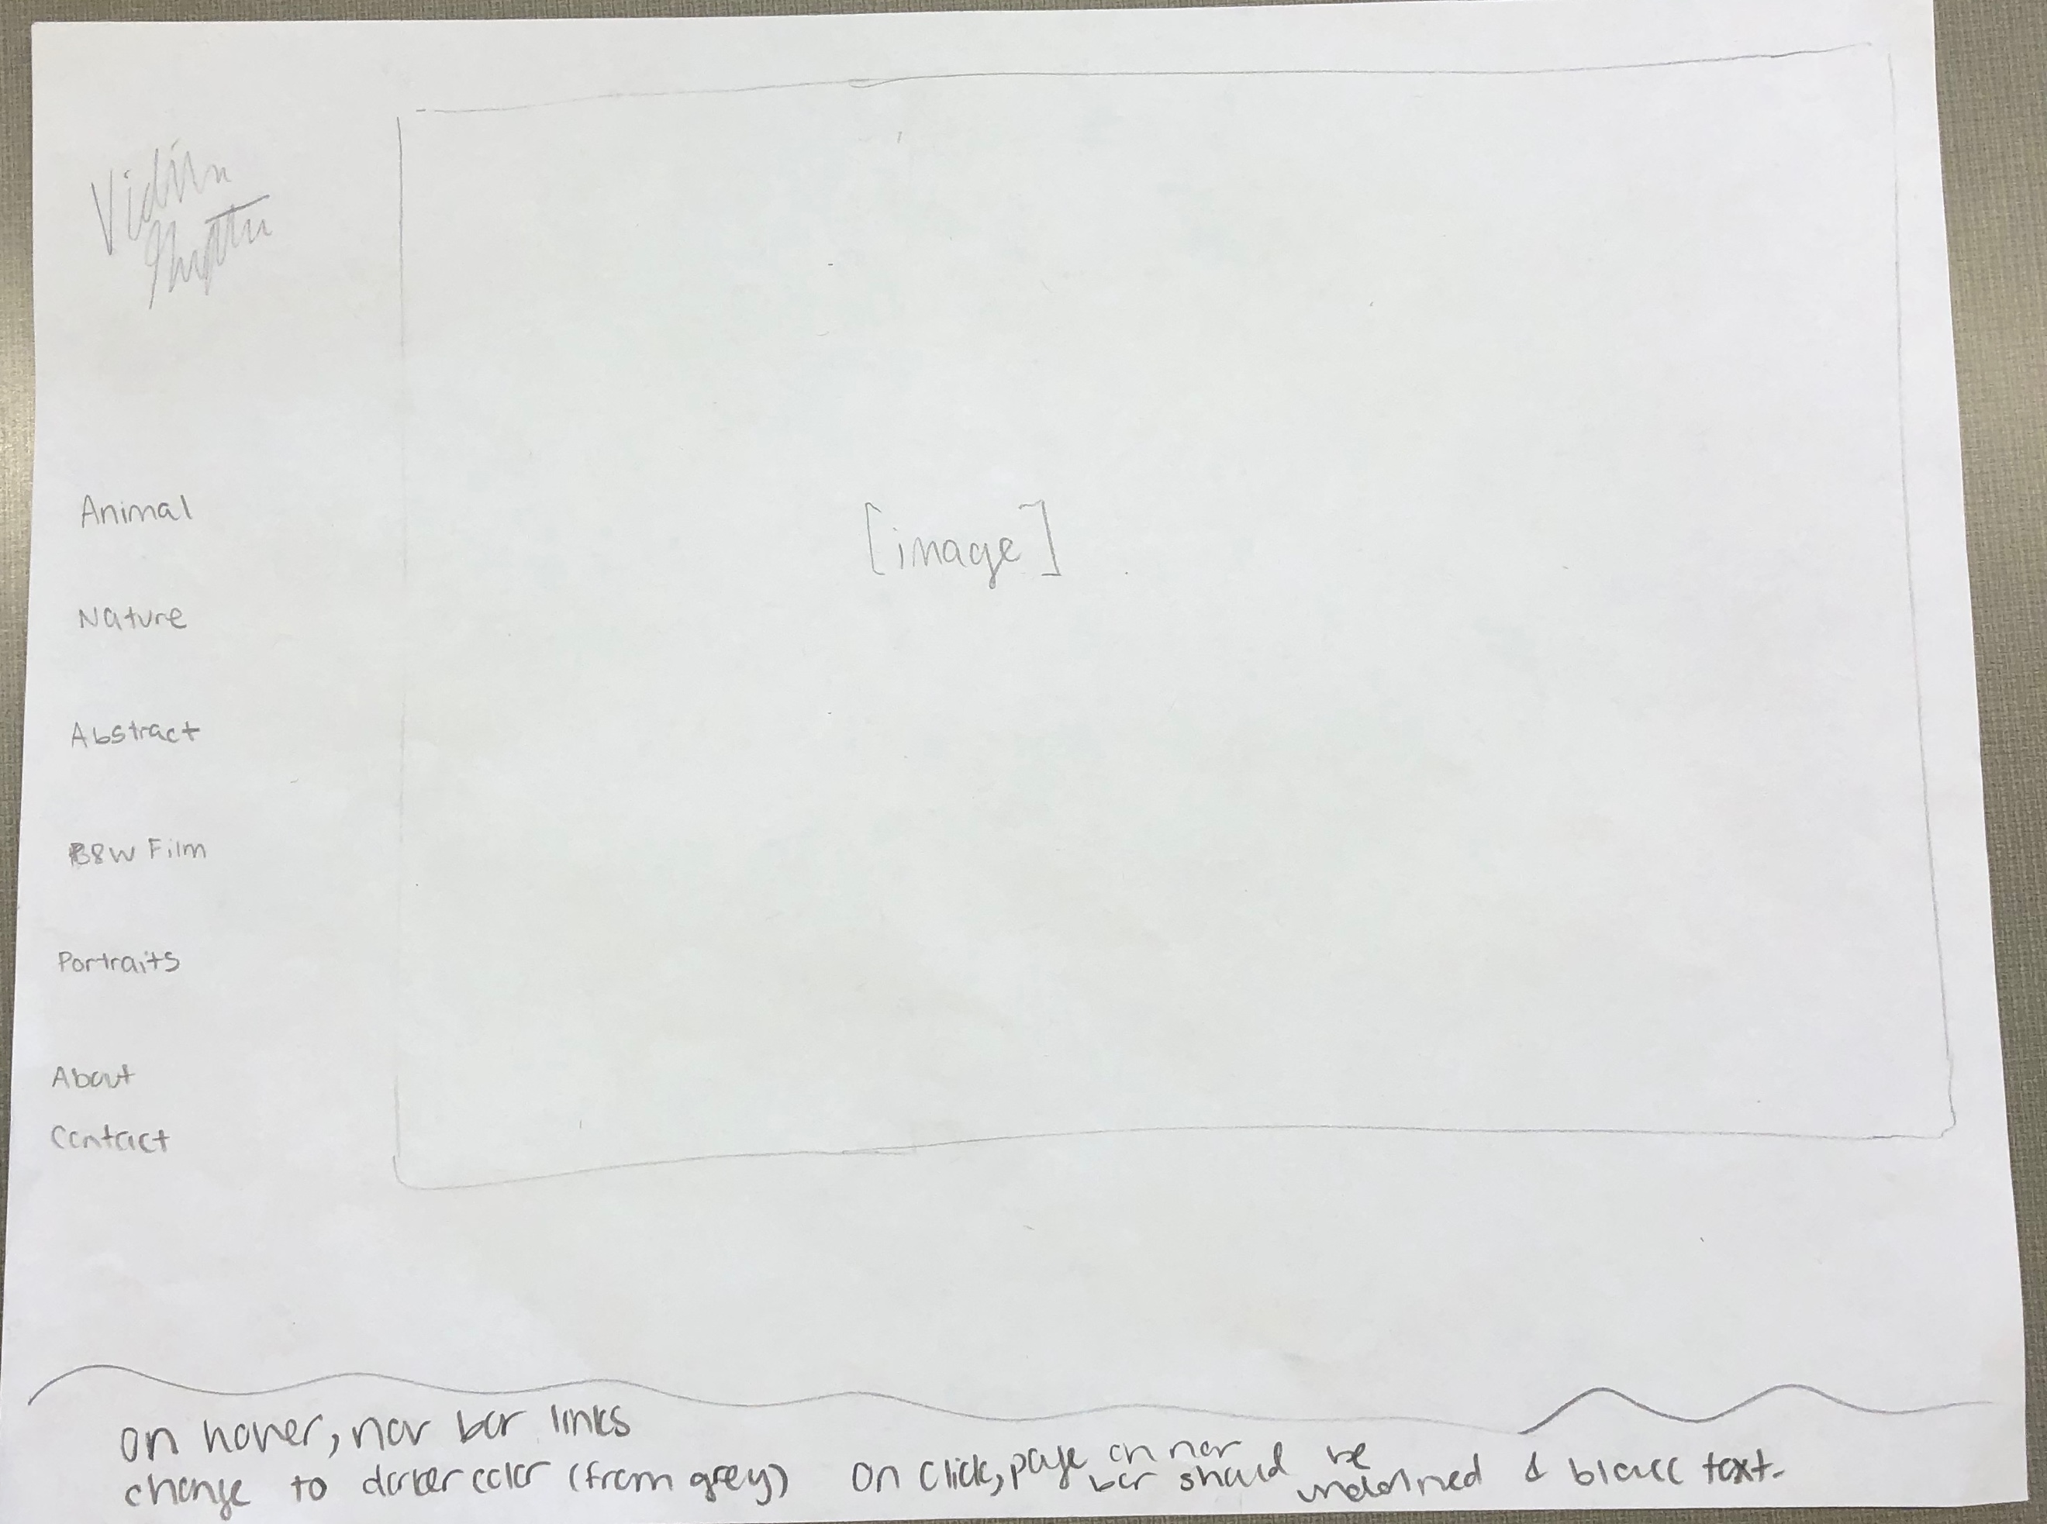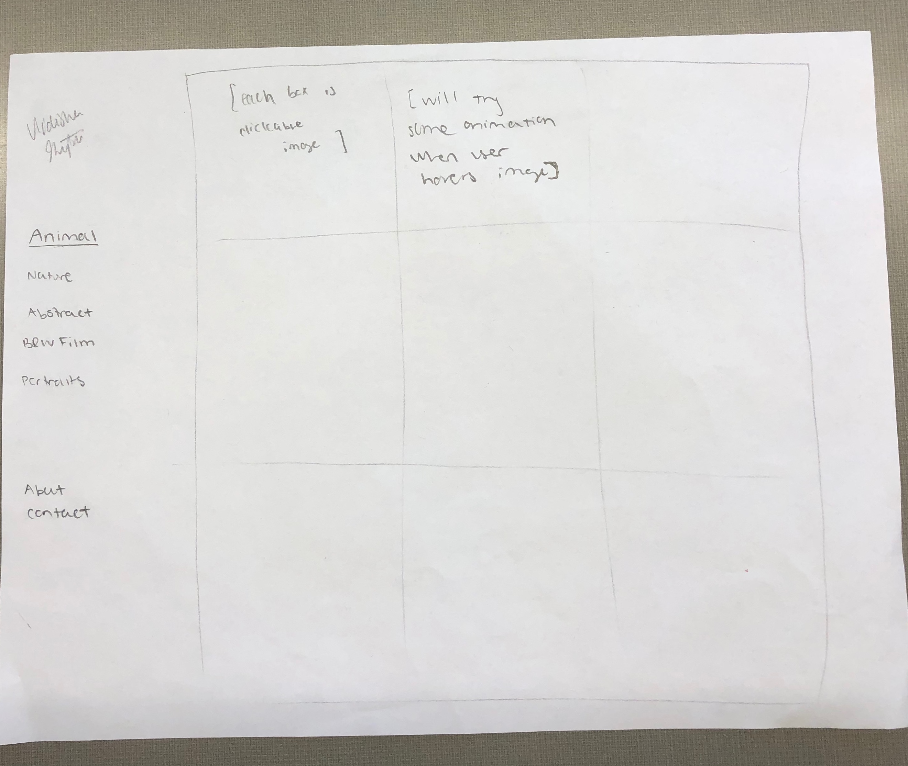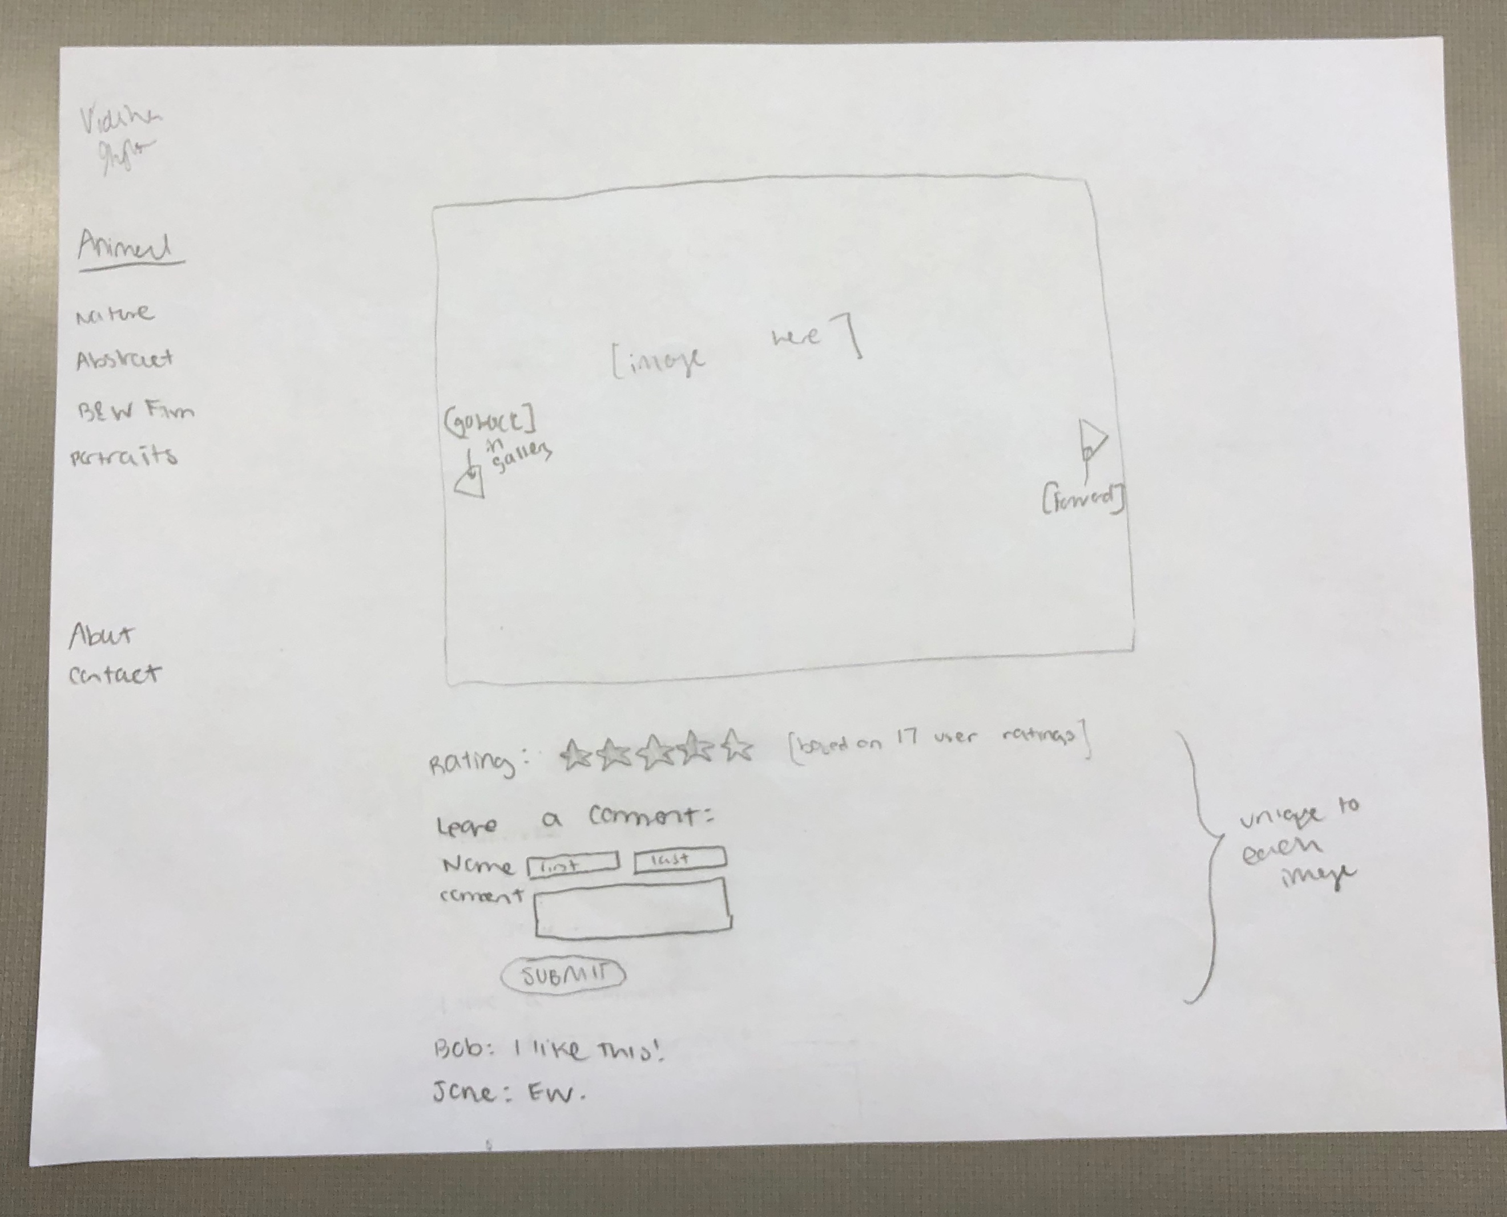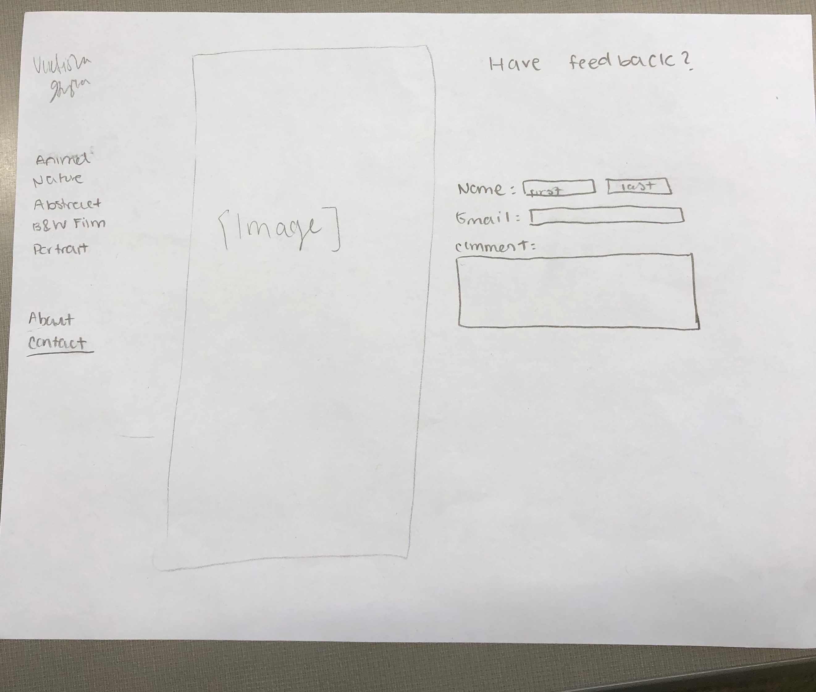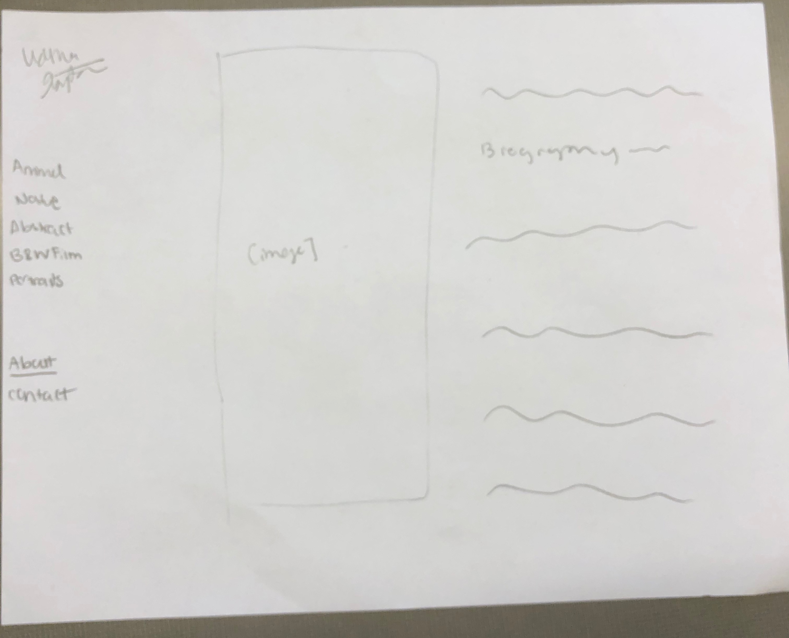

Design Testing Results:
- Tanvi
  - Wanted clearer link to the home page added home link to the navigation bar
- Daniel
  - Noticed that there wasn’t a submit button for comments page added button
  - Wanted add comment box to be located in a more accessible location moved to top of comments section

Prioritization of Features:
- Must do
  - Main home page is visually appealing and has a modern style
  - Each subpage (Animal, Nature, etc)
  - Users can leave comments on each image
  - Users can rate each image
  - Average rating is displayed on each image
  - Incorporate JavaScript where possible (try to animate things on hover, make gallery of images on click, etc)
- Extras
  - Add blog component
  - Add more subpages to the site
  - Create a page of user submissions (of photos)

Database Design:
- Photo table: has photo_id and url
- User table: has user_id, photo_id, and comment

Proposed implementation schedule:
- 11/3: Have navigation bar set up with some kind of design started for home page.
- 11/10: Have each subpage up and CSS mostly done. Upload images. Set up database.
- 11/17: Learn JavaScript, incorporate JavaScript into “slideshow” images and maybe try adding animations to each page
- 11/24: have website done
- 12/4: incorporate feedback from testing day and last minute changes
- 12/8: have presentation done

Potential Showstoppers and Open Questions: I think the most challenging part will be learning JavaScript without just copying things that I find online. I will try to watch a couple of tutorials online so that I’m actually learning a new skill.

