The Expanded Lakeside School Curriculum Guide
- Functional Overview: a short description of your project, including who your intended users are.

The Expanded Lakeside School Curriculum Guide is a comprehensive service for Lakeside students who need help picking their classes. The Expanded Curriculum Guide will not only include the classic descriptions found in the actual curriculum guide, but student provided ratings for each class that encompass the difficulty, class content, student engagement, standard of teaching, and level of fun of the class. Reviewers will also be asked to provide comprehensive statistics about the class such as amount of daily homework and the number of tests/projects per semester. Students will be able to utilize search bar functionality to find any class at lakeside. Classes will also be organized by grade level and subject matter.

- Design Overview: this should include pictures of your low-fidelity prototype. You can scan these in or use a high-quality phone camera. Let me know if you require assistance to get these scanned. (Next Page).

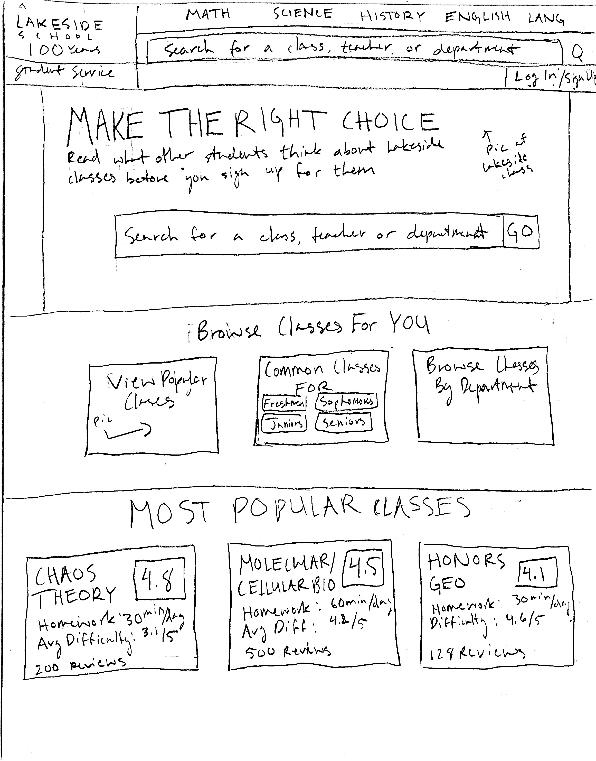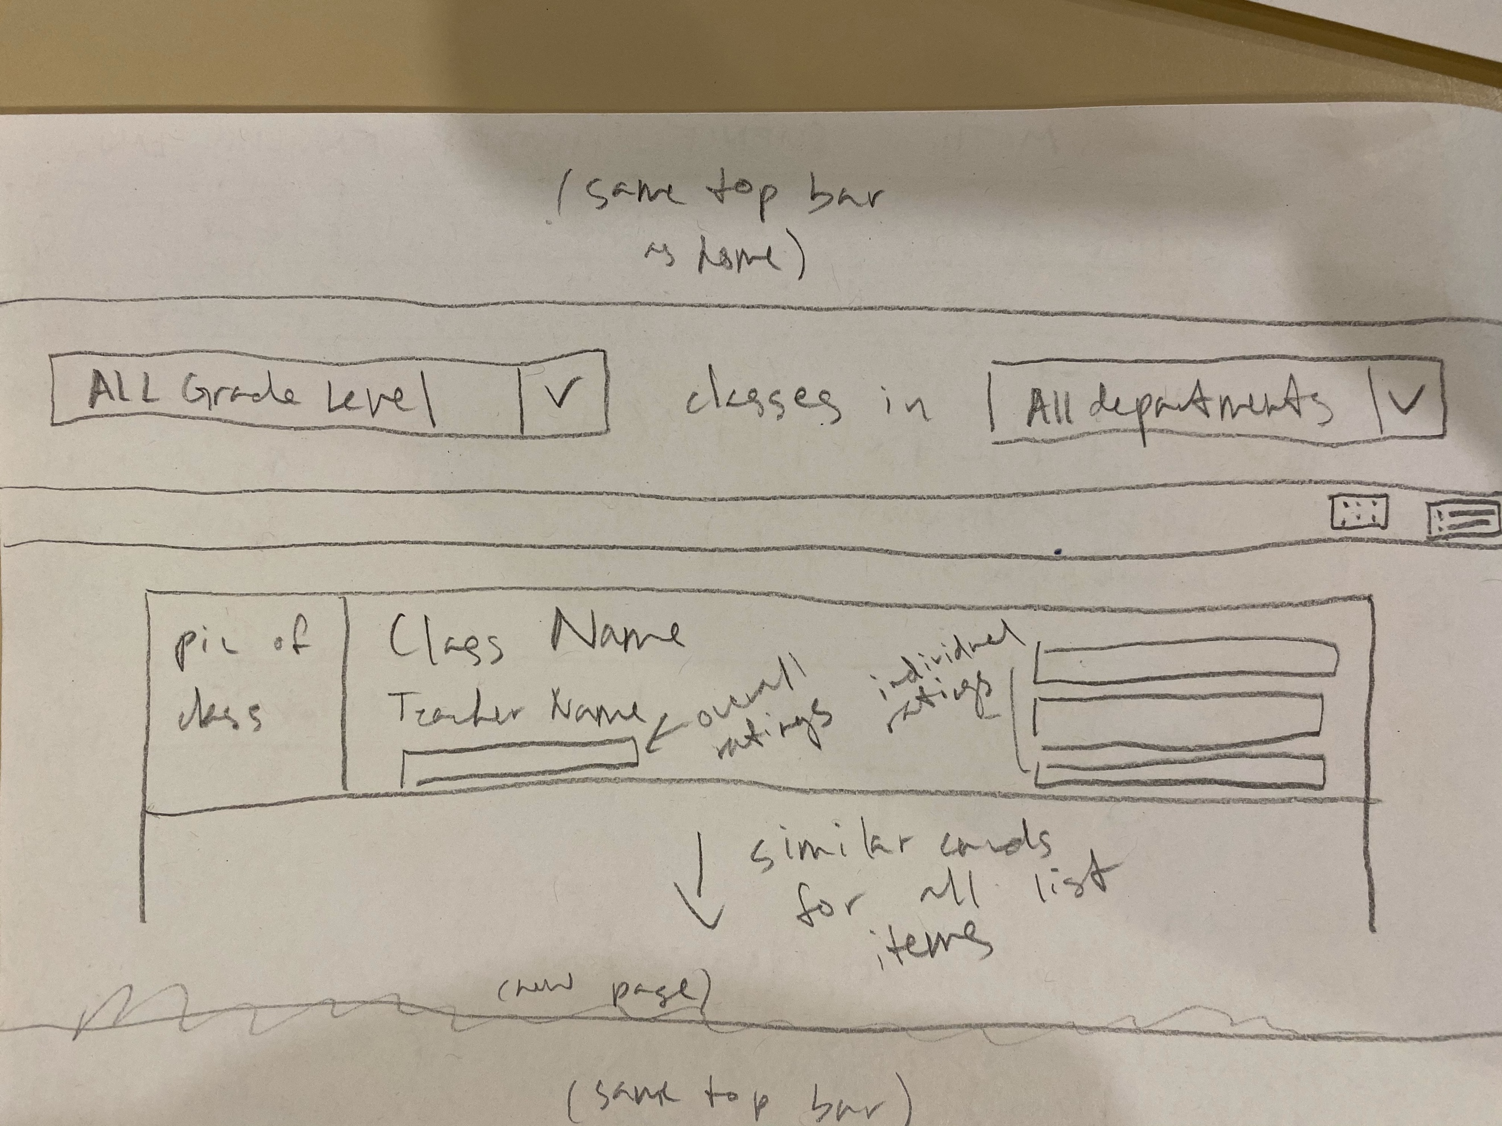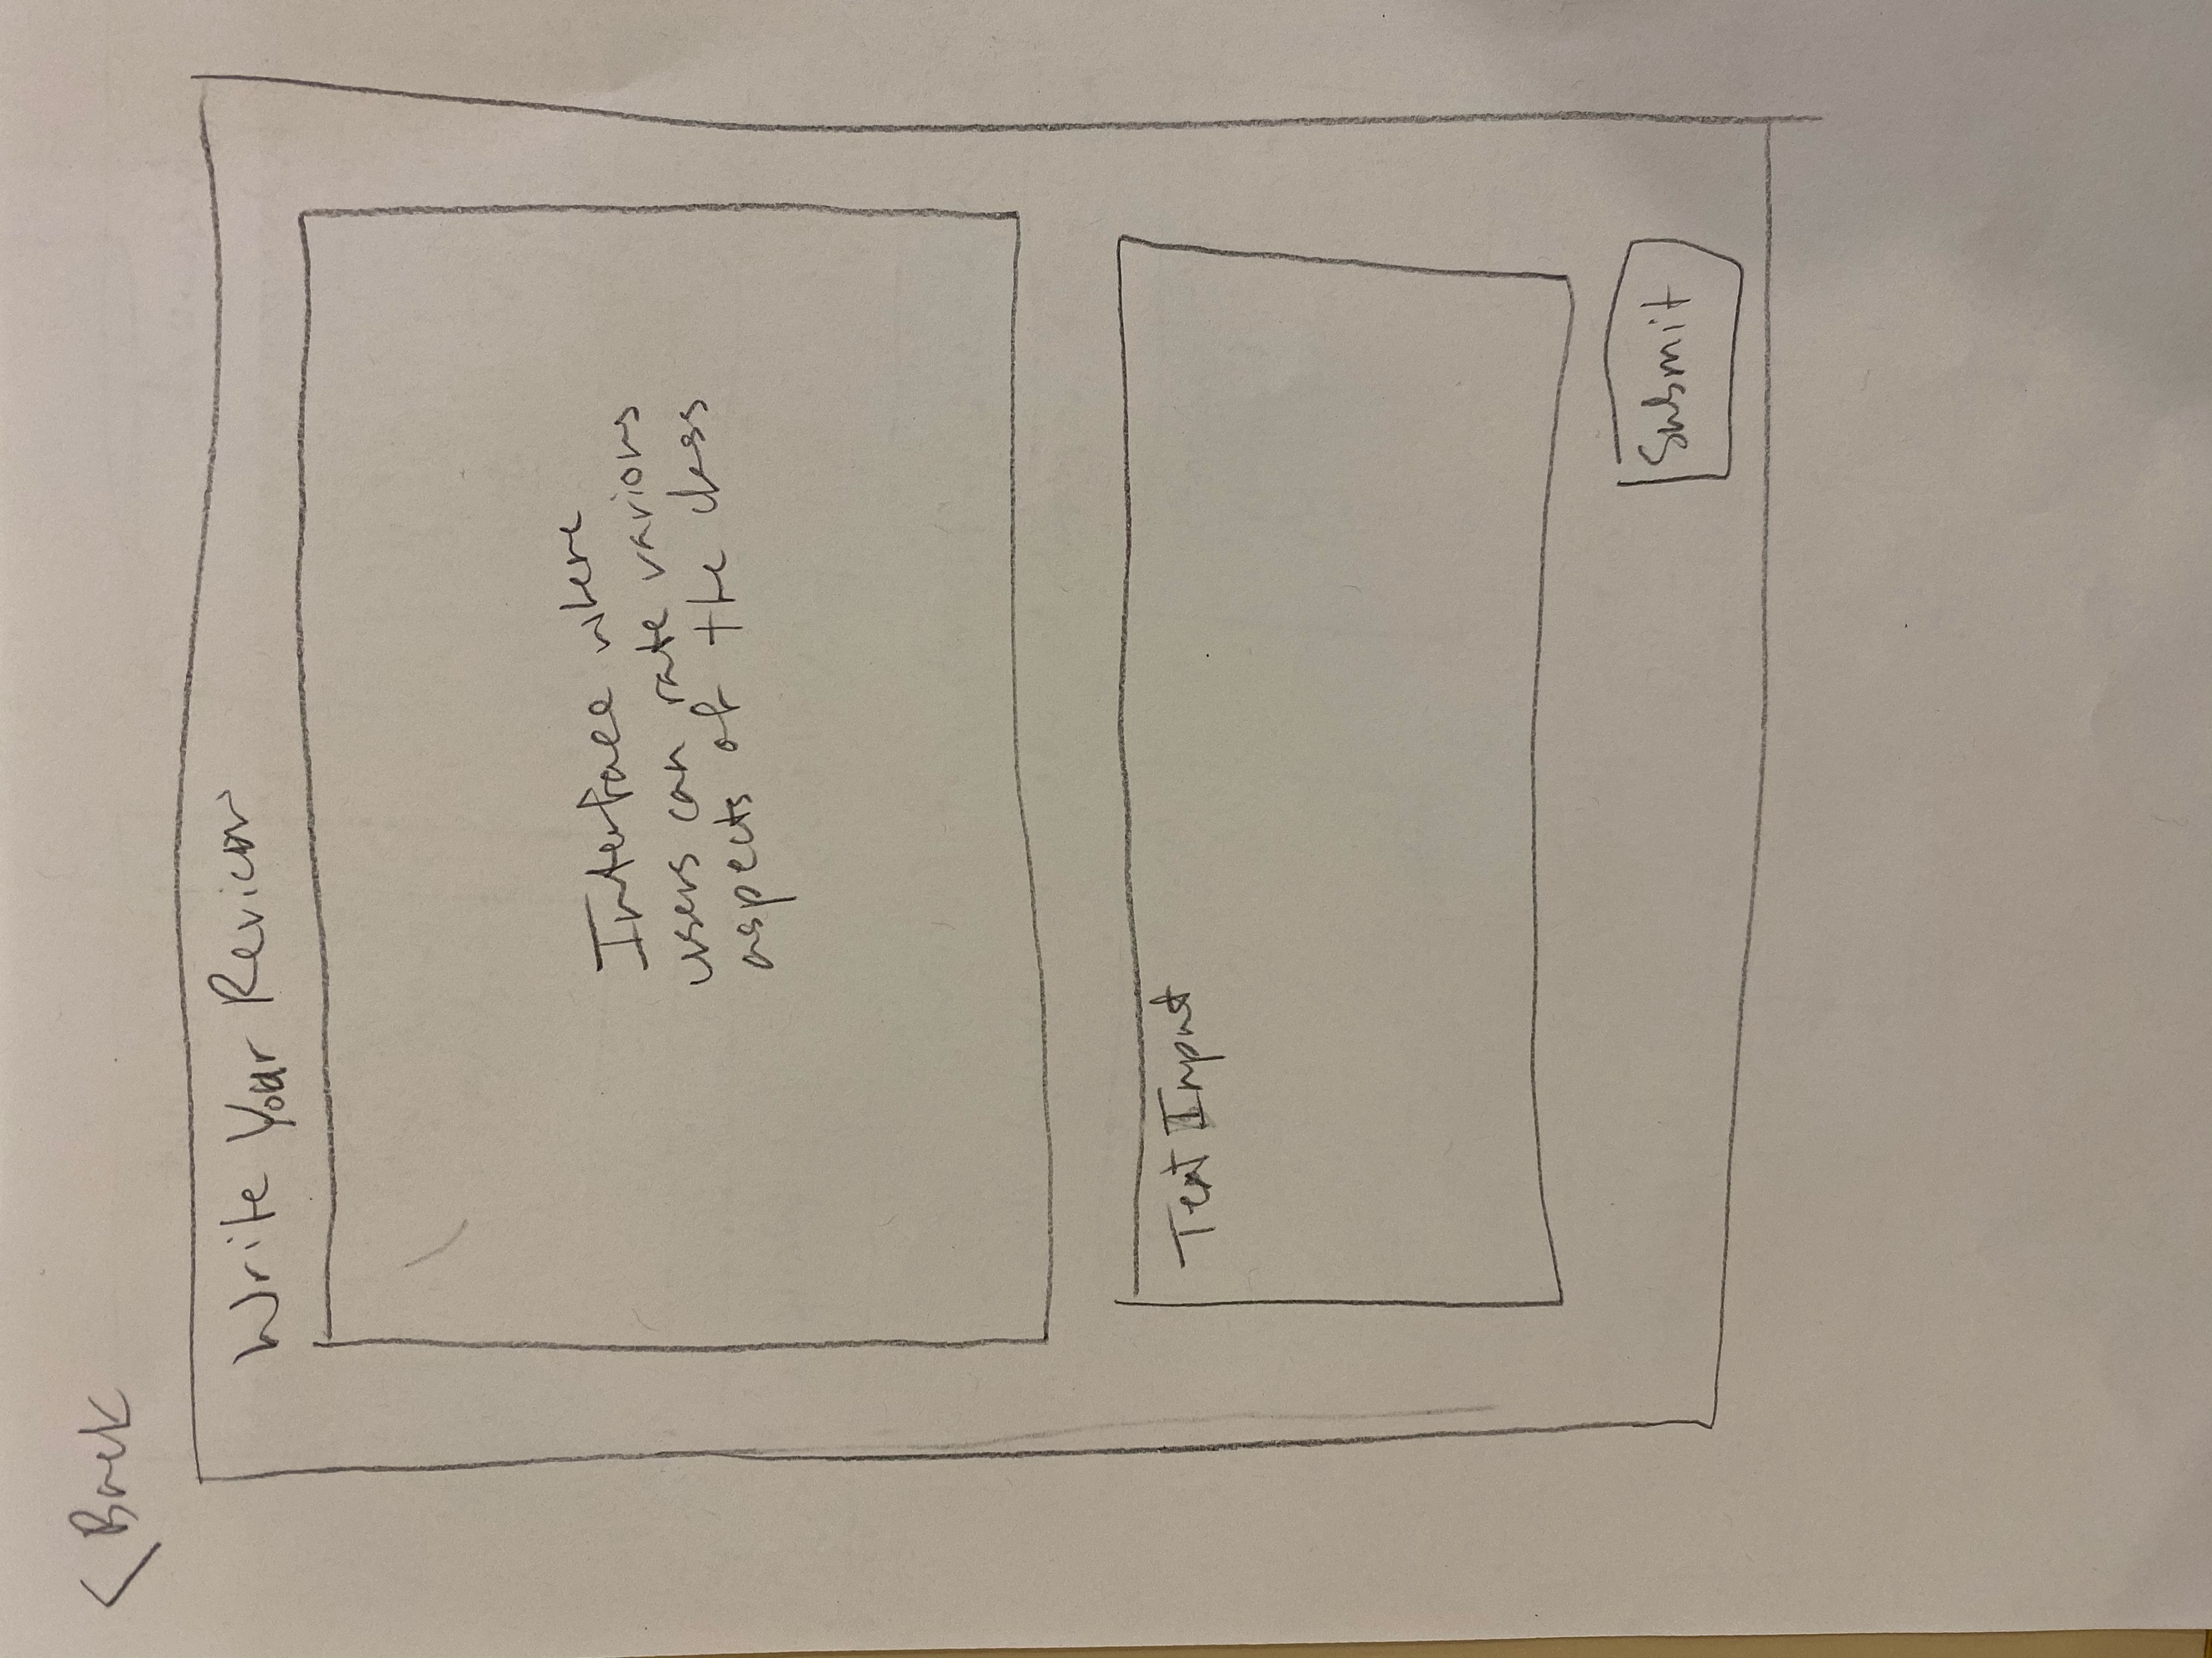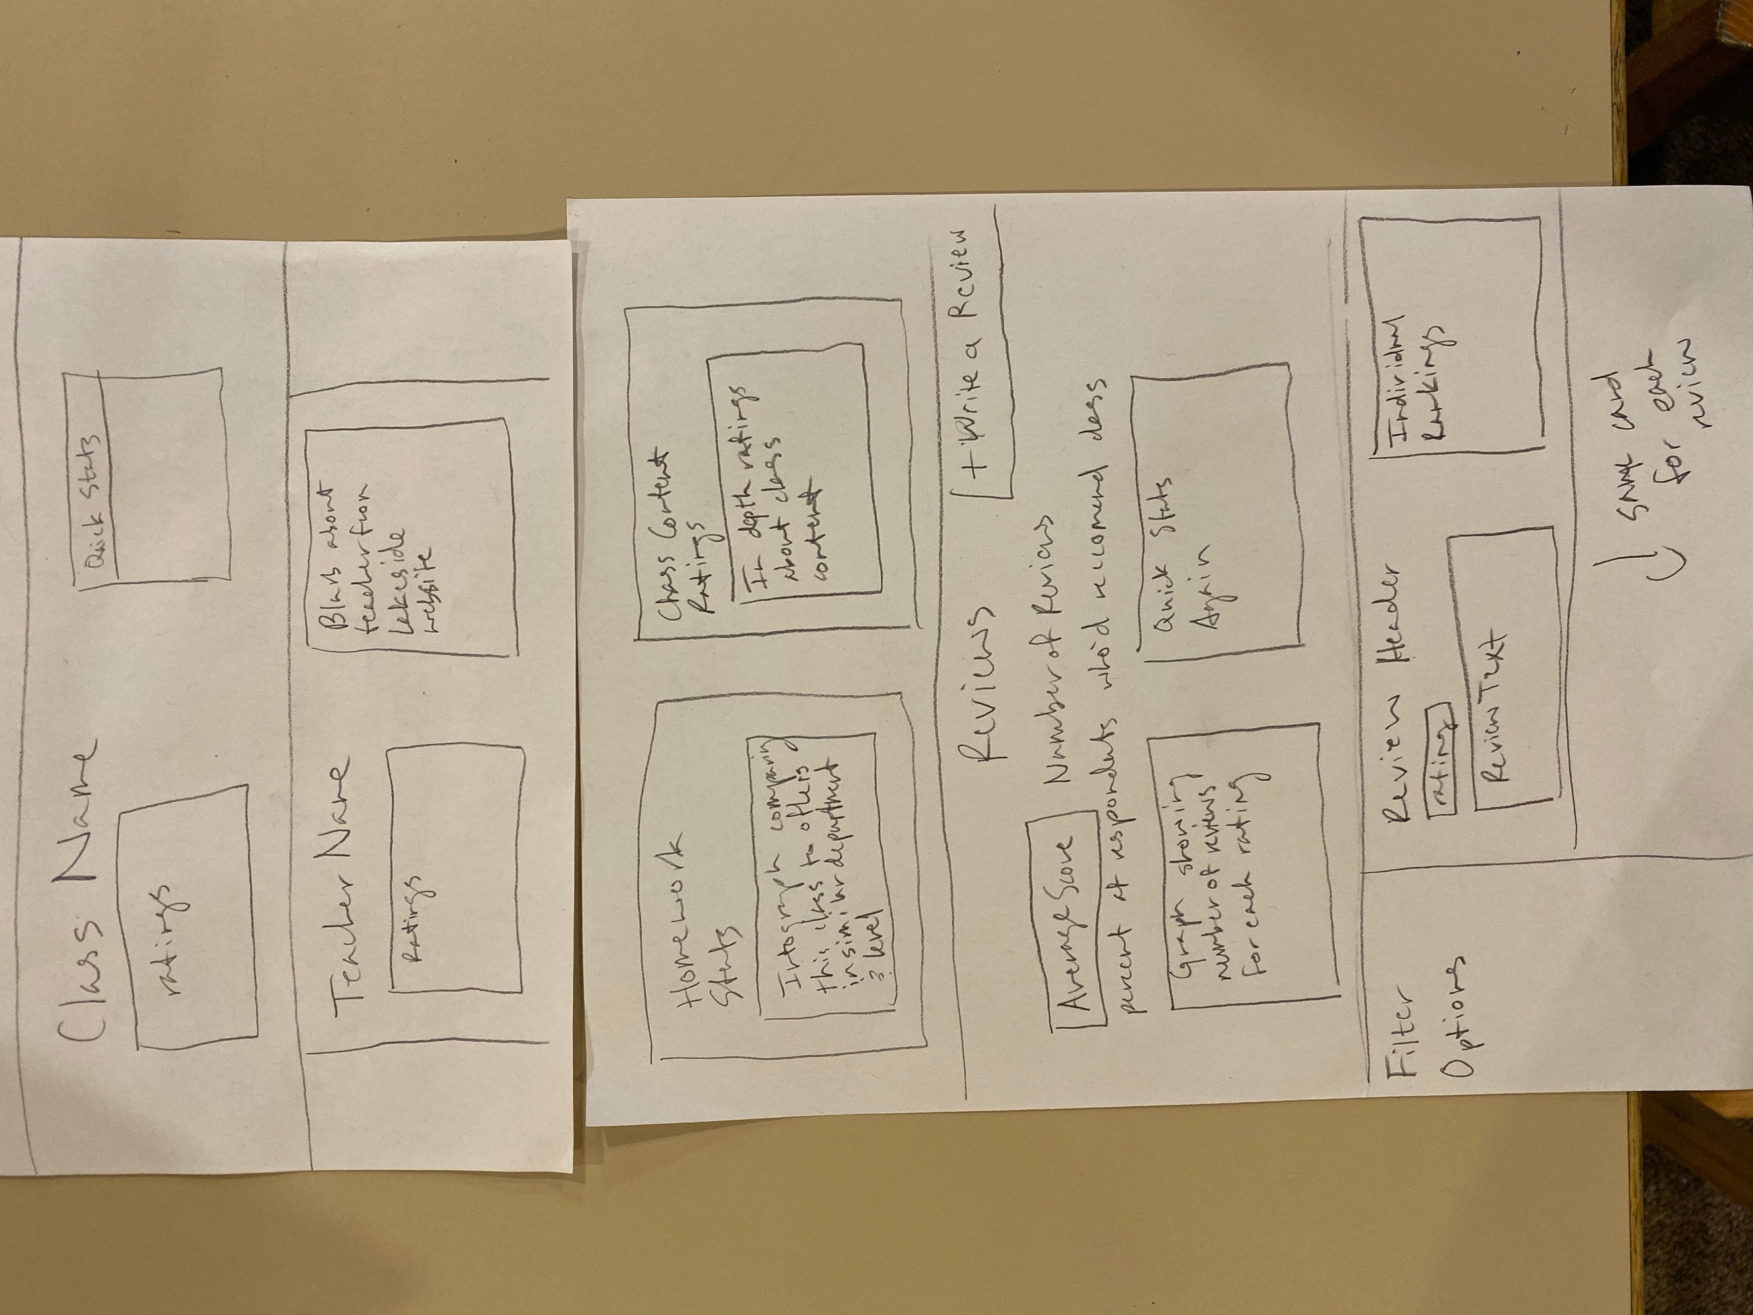

- Design Testing Results: list who tested your design (at least two people), and at least three things you changed in your design as a result of feedback from testers.

Vittorio Mount: Vittorio liked the design overall and didn’t have many points of concern. He was confused about how to exit the review popup so I added a back button

Ryan Tjoa: Suggested that commonly used words in reviews appear bolded. Suggested that items on the home page appear bigger so that it doesn’t seem cluttered.

What I changed:
- Added back button to review form
- Added bolded words in reviews
- Made home page items bigger

- Prioritization of Features: List all major features of your website, and separate your features into two groups: “definitely will implement” and “will implement if I have time”.

Definitely will implement:
- Display Lakeside courses from database with ratings/reviews table associated with each class
- LogIn Functionality that only accepts lakeside emails
- Allow users to view reviews from other users.
- Allow users to write their own reviews about any lakeside course.
- Allow users to search for classes by name, subject matter, and grade level

- Database Design: What tables do you expect to be in your database? What columns will those tables have?

- A table with every course offered. Courses have:
  - Ids
  - Names
  - Grade levels
  - Subjects
  - Overall rating
  - Number of reviews
  - Homework per day
  - Assessments/projects per semester
  - Average ratings in each category
- A table full of user reviews and ratings. Reviews have:
  - Ids
  - Ratings
  - Ratings for each category
  - Class ids
  - Review Text
- A table with user information (email and password)

- Proposed implementation schedule: List dates, and what features will be completed by those dates. Work backwards from when your code is due. Implementation schedule should list at least one milestone per week, if not more.

- By Monday Nov 4: Finish Databases
- By Monday Nov 11: Finish basic css layout for home page and review page
- By Monday Nov. 18: Finish search-bar functionality and connect pages in organized manner
- By Friday Nov 22: Add bolded word functionality for reviews
- By Friday Nov 29: Add all the courses and begin testing
- By Friday Dec 6: Turn in

- Potential Showstoppers and Open Questions: List any problems you think could come up in your project. Also list any outstanding questions or concerns.

- I don’t know how hard the bolded words will be but I’m confident in my ability to do everything else.

