My Closet Inventory

Functional Overview: This website helps you keep an inventory of the items in your closet, sorted based on the style, color, sizes, etc. of each piece. After you add in your closet, you can search for listed items based on filters and keywords, and the website will return matching results. Each user will have an account associated with their closet, so you must sign up and log in for My Closet Inventory, but you can add friends and search through their closets.

Design Overview:
- General view page, with sign up section and login button
- Login page
- User home page, starts at My Closet
- Individual item view
- Open menu and advanced search
- Profile and info page
- (Friends page) second priority, will draft pages if I decide there is time to implement
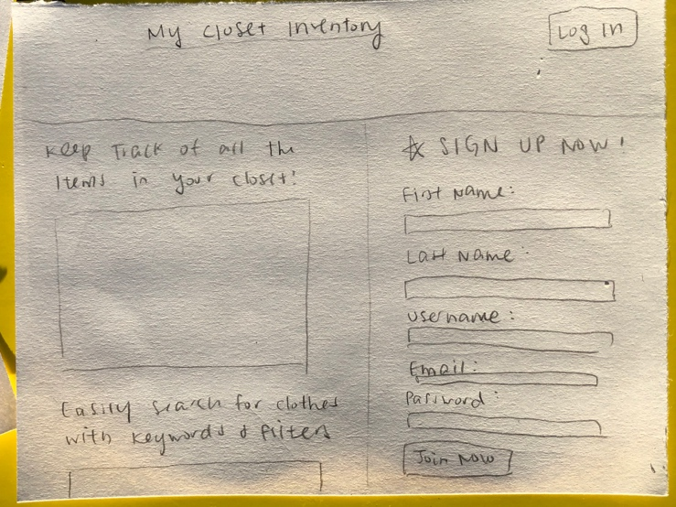 1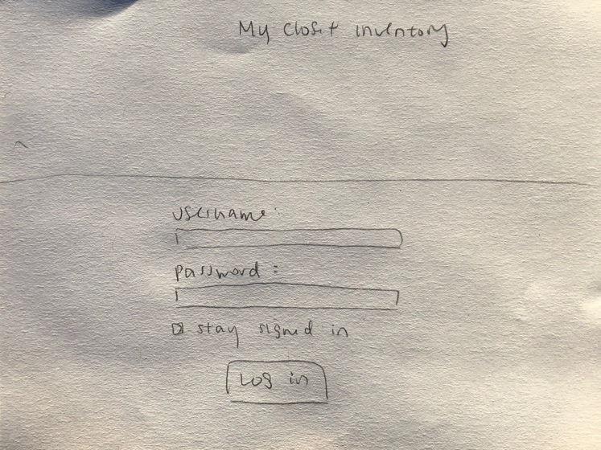 2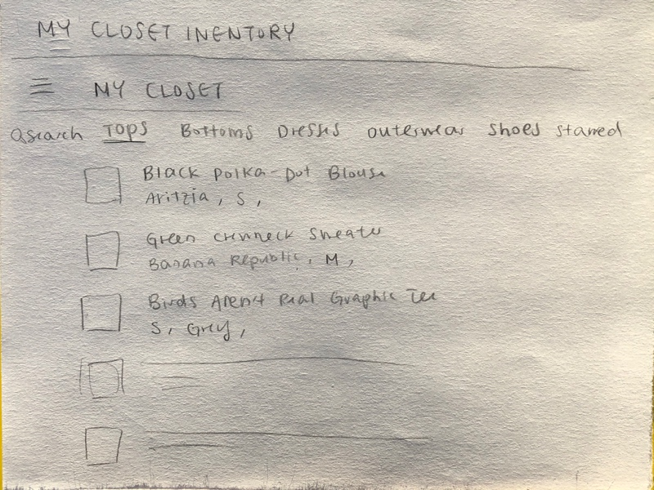 3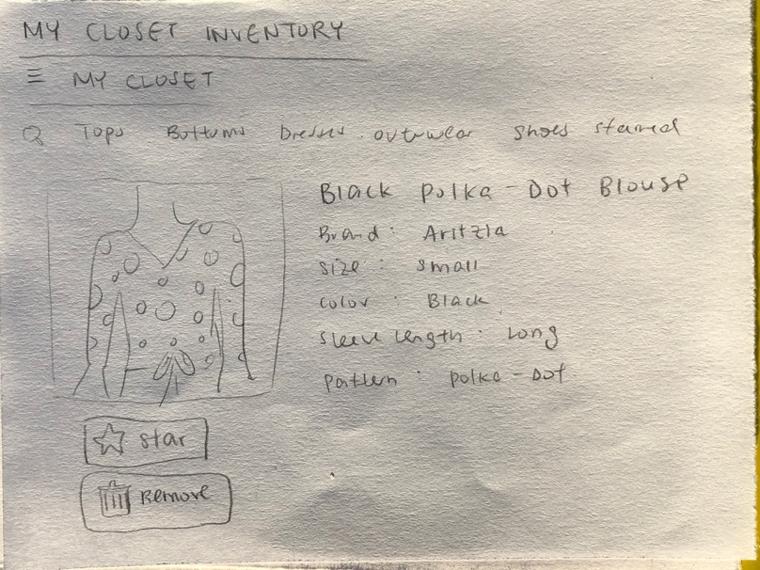 4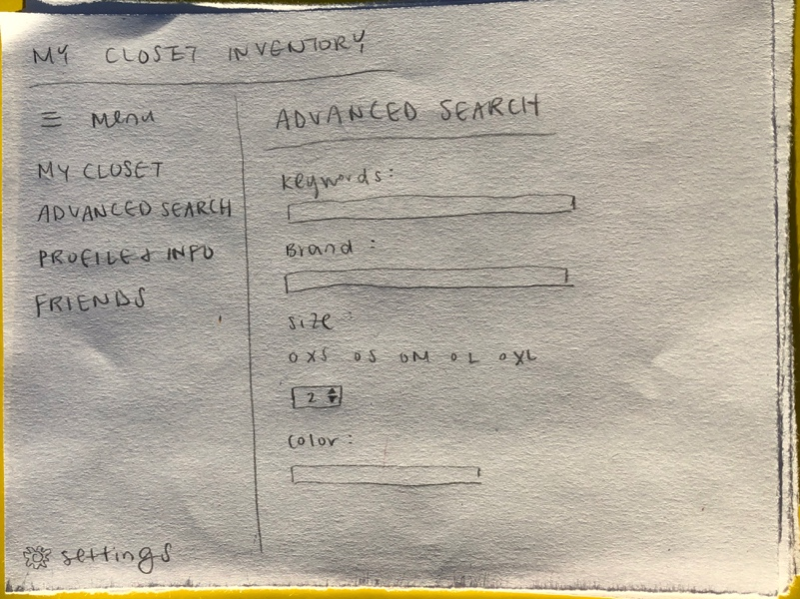 5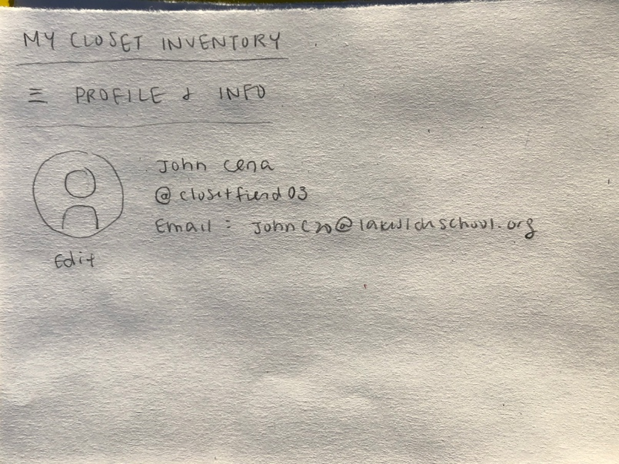 6

Design Testing Results (tested by Kelly Wang and Maxine Zhang)
-needed a JOIN NOW button on the sign up section
-ask for username in sign up so users can log in without their full name/profile
-separate between men’s and women’s closets (dresses, formal attire, heels, etc.)
-returned, donated, lost clothes have to leave the closet database
-make certain filters/specifications optional so users can add items without filling out everything

Prioritization of Features:
Must have:
-closet database
- add new items with tags
-search items based on keywords

Will implement if I have time:
-accounts and friends
-preset filters like color and style groups

Database Design:
Items table:
-id
-item name
-brand
-type of clothing item
-main color
-pattern
-fabric type
-sleeve length
-dress type
-pants rise

User account table:
-id
-name
-email address

Friendships table:
-id
-person 1
-person 2

Proposed Implementation Schedule:
10/30 Design doc
11/7 HTML framework and connections between pages and actions set up
11/11 Implement preliminary CSS Bootstrap
11/18 add search features and MySQL database
11/22 edit CSS to look good/fix any rough edges that I can find myself
11/27 Functional version ready for testing
12/6 Final Version

Potential Show Stoppers and Open Questions:
-how to get the menu to pop out without starting a new page
-needing to add another column to my database halfway through
-practicality of keeping all different clothing types in one database vs making separate databases for each big category

