Web Development Project
Design Document

Purpose:
To write a detailed design document outlining how you intend to build your website. This detailed design document will incorporate a visual component (low fidelity prototypes) as well as descriptions of design elements.

Assignment:
After you have created your wireframes, you are to write a clear design document. The document must contain the following sections:

- Functional Overview: a short description of your project, including who your intended users are.
  - In the game I will be creating, “Brain Racer”, multiple people can connect to the page from multiple devices and connect to a single game and compete against each other in fast paced brain testing tasks. The first thing the user will see on the site is a page where they enter their name and a button to enter the game. That button will then take them to a page which explains the premise of the game. The first person to enter the game will have the start button on this page as well. The first person to join the game is the only one able to start the game. Each user can see a list of people who have joined the game lobby, including themselves, so the game leader knows when to start the game. All users other than the leader will see a message, “The game will begin momentarily…” on the second page which will then lead to the first question of the game when the leader hits start. Once any player has submitted the correct answer to the question, every user will be sent to the second question and the person who answered it correctly will receive a point. If you answer the question incorrectly you unfortunately do not get any other attempts and will have to wait for another player to answer correctly. If no players answer correctly, then the game moves on to the next question and no players earn a point. After 7 rounds, the player with the most points, wins, and the final leaderboard will be displayed as well as whether you won or lost.
- Design Overview: this should include pictures of your low-fidelity prototype. You can scan these in or use a high-quality phone camera. Let me know if you require assistance to get these scanned.
- 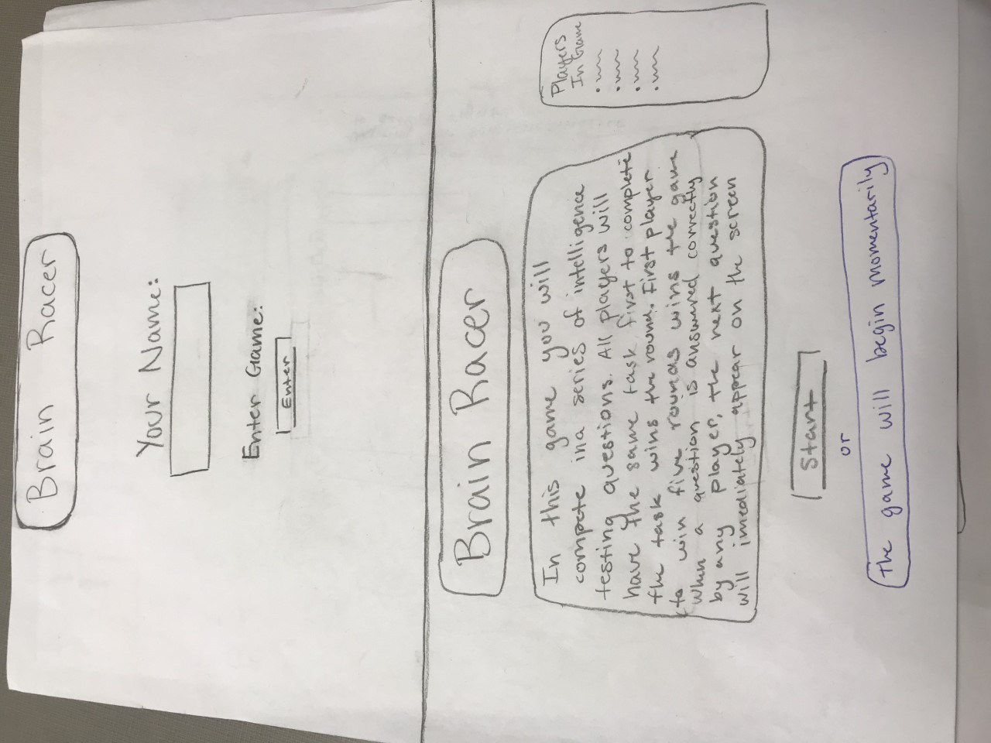
- 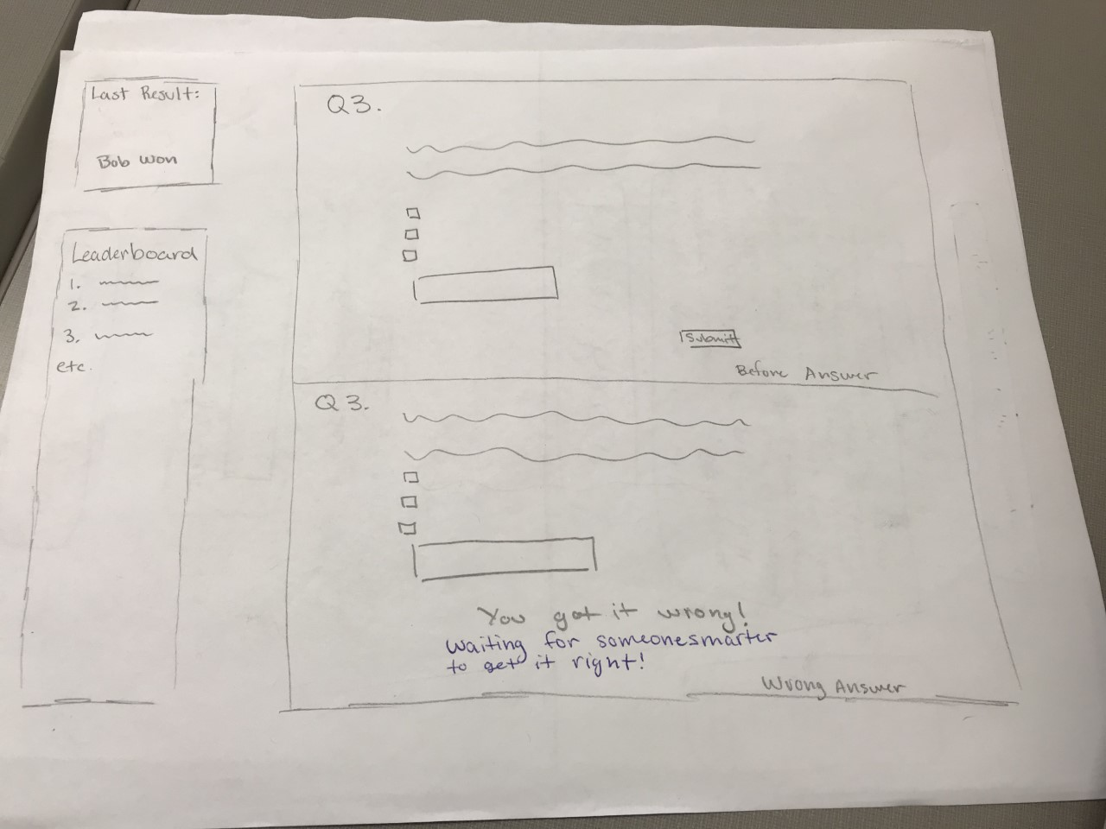
- 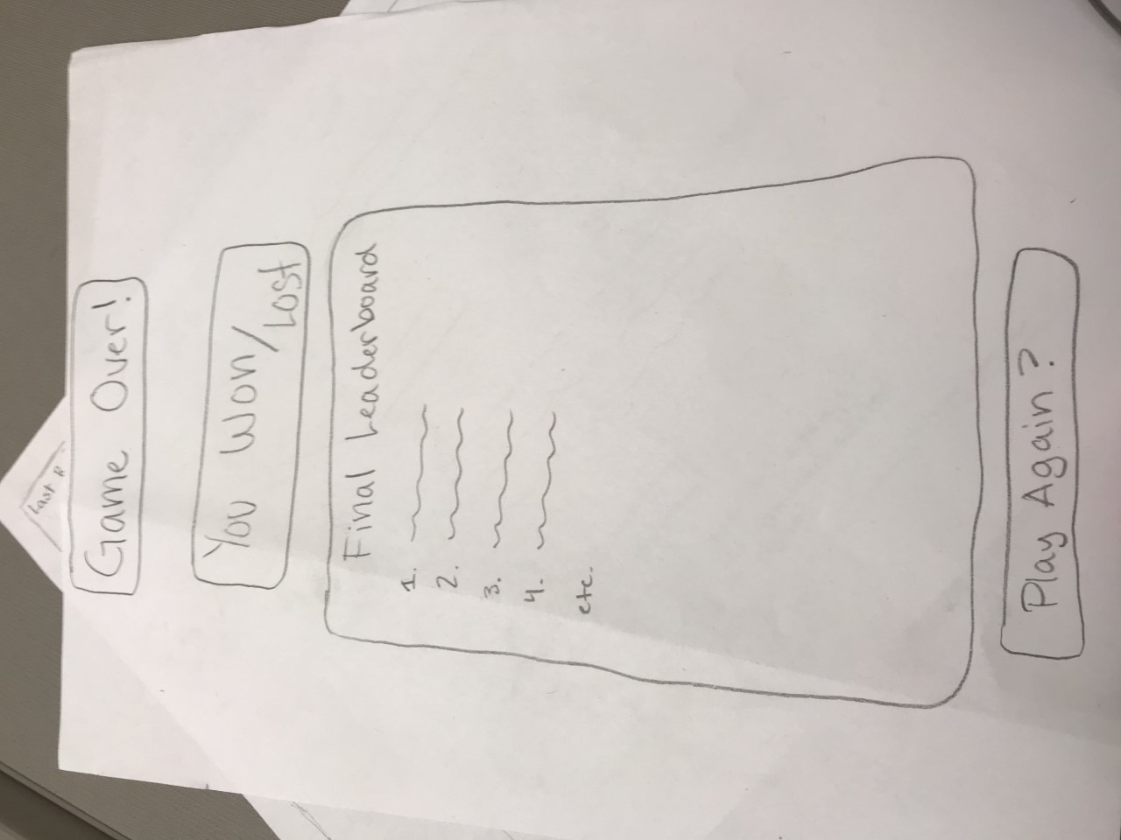
- Design Testing Results: list who tested your design (at least two people), and at least three things you changed in your design as a result of feedback from testers.
  - TESTERS: Alex Baker, Henry Evans
    - Feedback:
      - For all players but the leader of the lobby the second page will have a message saying the game will begin , momentarily
      - Also, a scenario needs to be added which deals where every player got the question wrong, if that happens, the game proceeds to the next question and the winner of the previous round is none
      - Add to incorrect answer message to include “Waiting for someone smarter to get it right”
- Prioritization of Features: List all major features of your website, and separate your features into two groups: “definitely will implement” and “will implement if I have time”.
  - Definitely will implement:
    - The basic mechanics of the game with multiple people playing the game at once
    - At least 7 different tasks for the players to do to fill the rounds
    - The final leaderboard and display who won and lost
    - Question answering mechanics like dealing with when a player gets a question wrong
  - Will implement if I have time:
    - Result of the previous turn
    - The current leaderboard at each turn
    - Who is in the game lobby before the game has started

- Database Design: What tables do you expect to be in your database? What columns will those tables have?
  - Table Results:
    - Columns:
      - Response_id
      - Round_id
      - Player_id
      - response
      - If time, game_id
  - Table Players:
    - Columns:
      - Player_name
      - Player_id
      - If time, game_id
  - Table Tasks:
    - Columns:
      - Round_id
      - Task_id
      - If time, game_id
  - If Time: Game Table:
    - Columns:
      - Game_id
      - In_Progress
- Proposed implementation schedule: List dates, and what features will be completed by those dates. Work backwards from when your code is due. Implementation schedule should list at least one milestone per week, if not more.
  - Nov 7th: Complete initial CSS designing
  - Nov 14th: Complete each html file individually
  - Nov 21st: Complete final interworking of the multiple pages and the functionality of the game with very simple one task
  - Nov 28th: Complete final tests and ensure all components work together as well as complete the previous game results and standings tabs
- Potential Showstoppers and Open Questions: List any problems you think could come up in your project. Also list any outstanding questions or concerns.
  - I think the big difficulty will be with having the multiple web pages interact in real time.
  - How important is the difference between all the sites refreshing and loading simultaneously and 1/3 of a second?

