CS 4 Web Application Design Document: Trust.io
By Victor Xia
Functional Overview: Trust.io is a game in which users earn points and make agreements over six rounds of play. Users register upon landing on the site and then are entered into a room with 2-5 other players. They must then either navigate choices of Income, Trade, or Backstab – a simple game that the target audience of casual players are sure to pick up on quickly. The winner at the end is the player with the most points, and win-loss records are kept for each player, displayed on a leaderboard at the landing page.

Design Overview: There will be an HTML Form landing page, and upon submission or registration of a screen name and password, a JavaScript game room is enabled, showing a simple list of player names and a scoreboard. Each player is highlighted during their turn, during which buttons are enabled on other players indicating Trade, and a button shown indicating Income. If a player decides to trade with another player, a dialog opens for the other player prompting to confirm trade (mutual benefit) or backstab (initial player loses points).

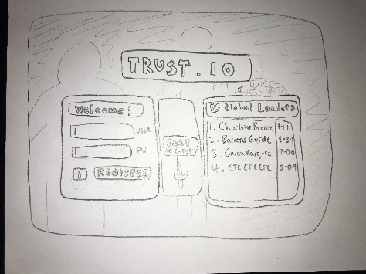 | 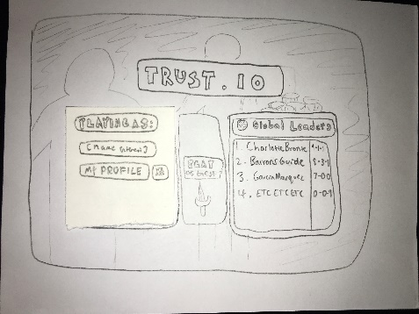 | 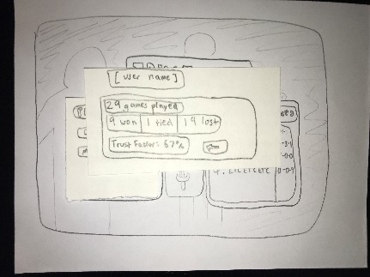
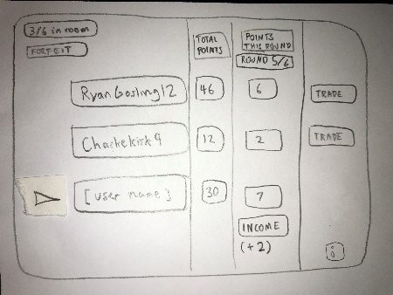 | 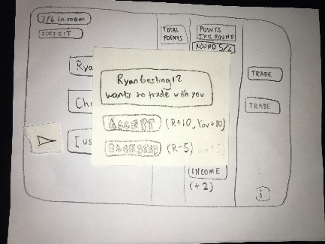 | 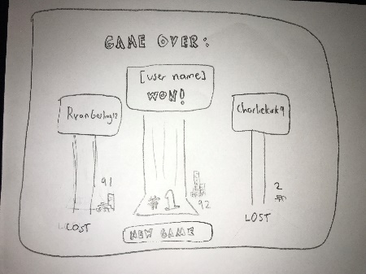

Design Testing Results: Vincent and William tested my prototypes. William suggested having just a single trade button which highlights other players’ names upon selection. I also decided to adopt his suggestion for gameplay, having a backstab be only points subtracted to the initiating player, not points also added to the backstabbing player. This ensures backstabbing is not game-breaking and overpowered. I also added a help button in the bottom corner of the game room interface, upon William’s request. Vincent suggested and I agreed that the benefit of a trade be skewed in the favor of the initiating player, making trades more attractive and inspiring more active gameplay.

Prioritization of Features: The most important features will be log-in and registering, the three realtime mechanics of the game room itself, and the score-keeping and record system, as well as the CSS for the landing page and the game room. If I have time, I will implement a publicly displayed trust factor for each player (based on previous interactions), extra actions, such as one in which the initiating player loses many points and the other players lose a few, and I will further refine the CSS/user interface. I’d also like to create “bots” for players to play against in an empty room.

Database Design: I expect to have a table for with columns for player names, their passwords, their total points [and trust factor], as well as a separate table for recording individual games, with columns indicating player id, and points accrued during that game. This relationship is many-to-many, as each player may have been in many games and each game may have many players.

Proposed implementation schedule:

Design doc. due Oct. 30th
Player interactions (game database, turns, and dialog boxes) done by Nov 4th
Log-in system (player database) done by Nov. 11th
Teacher check-in on Nov. 14th
Full game functionality done by Nov. 18th
All CSS finished by Nov. 25th
Testing day on Nov. 27th
CSS tweaks and debugging done by Dec. 2nd.
Project due Dec. 6th
Potential Showstoppers and Open Questions:
The turn-by-turn nature of the app will require experimentation, and implementation of AJAX. It should be straightforward to have an updating scoreboard reflect changes in the game database – however, I anticipate the dialog box prompted by the Trade action will be more difficult, as it is coordinated between users. I can see the mechanics of the game itself as requiring some experimentation too, ensuring that there are no imbalances or game-breaking situations. Finally, the user interface will require a lot of work, especially the paths to entering and exiting each game.

