Thomas Yim
Meeting Planner
29 October 2019
Functional Overview
Students at Lakeside are always struggling to find times to meet with teachers about questions they have in their classes. With lunch, departmental meetings, and reserved times with other students, teachers are often unavailable even when they do not have classes. This website will solve this problem by being a sign-up sheet for students to find times to meet with teachers. The intended users are Lakeside students and the teachers they want to meet with. The user will be able to reserve a time, and the teacher will be able to confirm meetings and block out times for lunch and other activities.
Design Overview
The first page will have four options: log in as a student, sign up as a student, log in as a teacher, and sign up as a teacher. If you chose a log in option, then it will take you to a page to ask for the email and password. If it is a student signing up, it will take their name, email, and password. If it is the teacher, it will ask for the name, email, password, and department. It will then take the teacher to a page where they can select what periods they have class and how many times it meets a week. The teacher home page will have a big schedule in the middle where the blocks with classes are not able to be changed. They can confirm meetings that students request or deny them. They can also add events to open blocks. The student home page will have a filter that they can use to search for teachers and request meetings. Both students and teachers will have a change info page where they can change their information.
See images below.
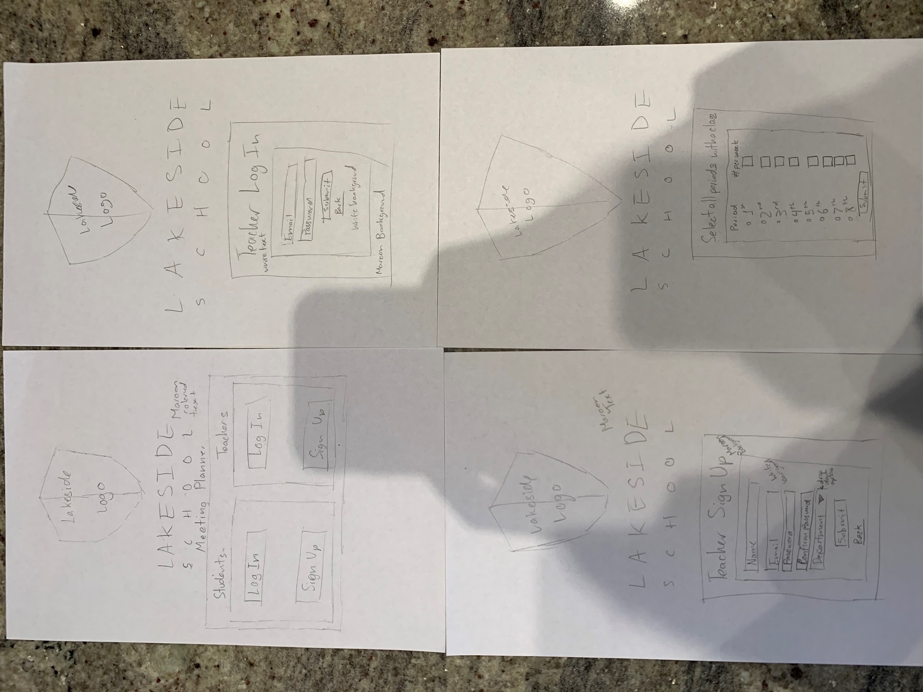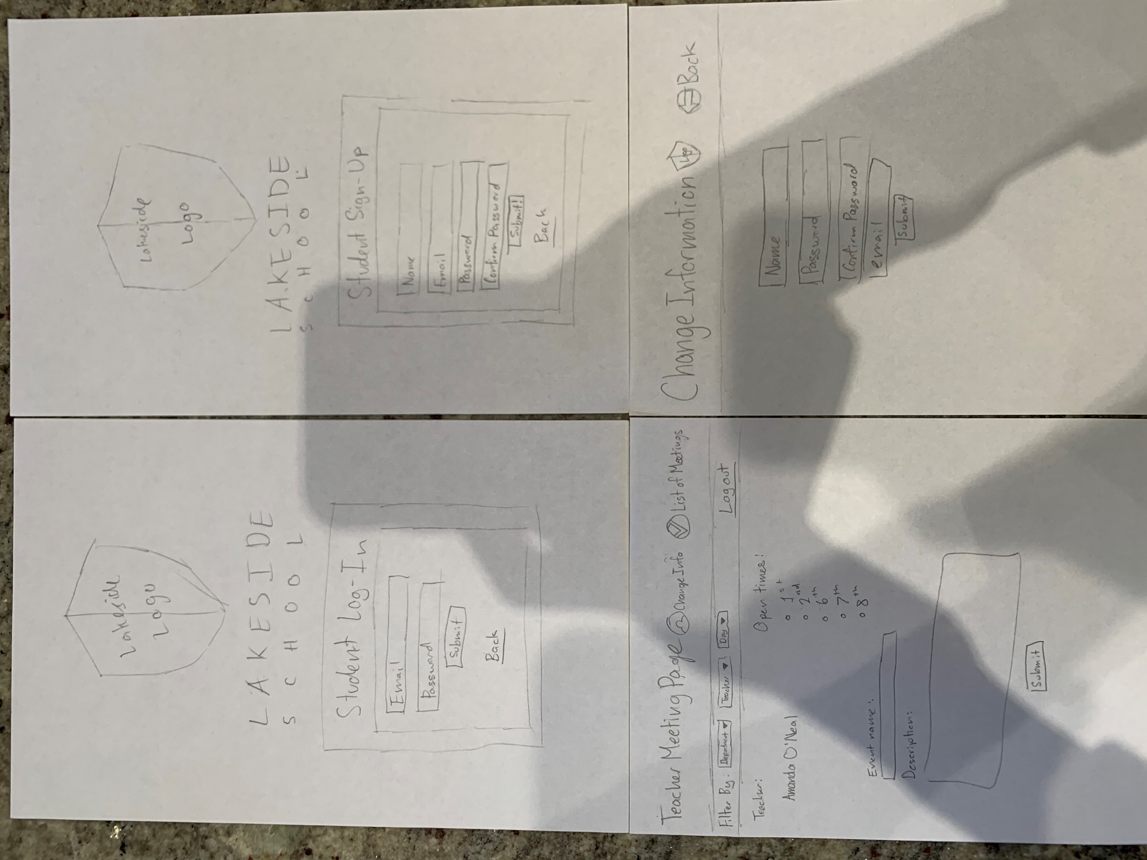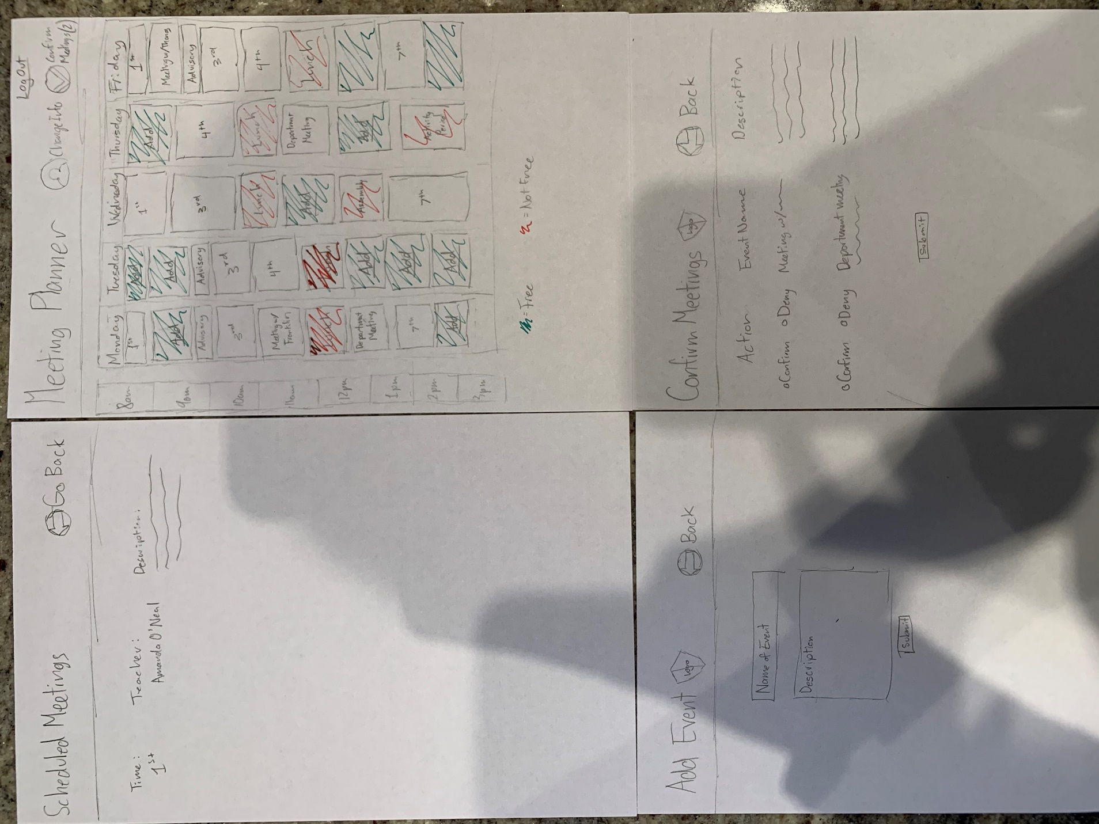

Design Testing Results
Philip and Franklin tested my design. They recommended the following:
- Add back button to 4 way sign up
- Add confirm password to sign up and change information
- Add log out button for the student and teacher main page
- Add deny button option for the meeting confirmation page.
Prioritization of Features
Definite Implementation:
- Teachers will be able to create an account with their email, name, department, and password
- They will be able to set up their class schedules on the website.
- They can block out certain times for department meetings of meetings with other students.
- Students will be able to create an account with an email, name, password, and grade
- They can filter through subject, teacher, and day for the available teachers.
- They can see the available times to meet with a teacher and request a meeting.
- Students will be able to submit a description of the purpose of the meeting.
- After the meeting is reserved and requested, the teacher can either confirm or deny it. That teacher will see the proposed time and the description the student submitted.
- When the meeting is requested, the time will be blocked so that others don’t request it.
- The student will have a page that lists all of the meetings they have set up.
Possible Implementation:
- Some form of notification system to remind both the student and the teacher of the meeting
- A way to confirm using email if the user is who they claim to be
- Finding a way to automatically upload the teachers’ schedules from Veracross
- Account for special weeks.
Database Design
The table Tyim_teachers will contain a list of all of the teachers with accounts on the website.
Tyim_teachers | Id | Name | Email | Department | Password
Example | 1 | Amanda O’Neal | Amanda.ONeal | Computer Science | Password123

The table Tyim_students will contain a list of all of the students with accounts on the website.
Tyim_students | Id | Name | Email | Password
Example | 1 | Thomas | ThomasY21 | Soccer123

The table Tyim_meetings will contain a list of all the meetings. It will show who is involved in the meetings, whether or not the teacher has confirmed the meeting, and the message corresponding with the meeting.
Tyim_meetings | Id | Student_id | Teacher_id | Confirmed | Message
Example | 1 | 1 | 1 | Yes | Check Test Corrections

The table Tyim_teacher_schedule will contain a list of all the classes and meetings teachers have for each block of the week. It will have a column for the teacher_id, Monday 1st period (M1), Monday 2nd period (M2), and so on.
Tyim_teacher_schedule | t_id | M1 | M2 | M3 | M4 | M5 | M6 | M7 | M8 | …
Example | 1 | First | Free | Third | Lunch | Free | Free | Seventh | Free

Proposed Implementation Schedule
11/8 – Create Database and create login, setup, and change account functions for the teachers and students
11/11 – Create the filter for students to find a list of teachers.
11/14 – Allow the user to request a meeting and allow the teacher to confirm or deny it
11/19 – Create interface to show the teacher’s schedule
11/22 – Write the CSS to show teacher schedule in the format shown in the low-fidelity design
11/26 – Create page for the student to see all of the meetings they have scheduled.
11/27 – Test the website.

Potential Showstoppers and open questions
What happens if I cannot format the schedule the way I want to?
How do I make it so that the size of the block on the website corresponds with length of meeting?

